**Photography Style**

**1. Camera and Lens Photography**

1. Digital Photography
2. Film Photography

Golden hour allows you to have a bit more natural light to work with. The golden hour enhances silhouettes and casts a magical, hazy glow over the seascape.

1. Smartphone Photography
2. Drone Photography
3. Tilt-Shift Photography
4. Pinhole Photography

**2. People Photography**

1. Portrait Photography
2. Self-Portrait Photography
3. Wedding Photography
4. Sports Photography
5. Music Photography
6. Event Photography
7. Fashion Photography
8. Family Photography
9. Child Photography
10. Newborn Photography
11. Headshot Photography
12. Boudoir Photography
13. Glamor Photography

**3. Nature Photography**

1. Landscape Photography
2. Wildlife Photography
3. Bird Photography
4. Pet Photography
5. Macro Photography
6. Sunset Photography
7. Ocean Photography
8. Underwater Photography
9. Cityscape Photography
10. Aerial Photography
11. Astrophotography
12. Panorama Photography

**4. Reportage Photography**

1. Photojournalism
2. Documentary Photography
3. Street Photography
4. Travel Photography
5. Urban Exploration Photography
6. Editorial Photography
7. War Photography
8. Action Photography

**5. Artistic Photography**

1. Fine Art Photography
2. Still Life Photography
3. Abstract Photography
4. Minimalist Photography
5. Fantasy Photography
6. Multiple Exposure Photography
7. Composite Photography
8. Time-Lapse Photography
9. Long-Exposure Photography
10. Blacklight Photography
11. Black-and-White Photography
12. Flat Lay Photography
13. High Dynamic Range Photography
14. Crystal Ball Photography

**6. Photography for Business**

1. Product Photography
2. Food Photography
3. Architecture Photography
4. Real Estate Photography
5. Social Media Photography
6. Commercial Photography

**1. Camera and Lens Photography**

1. Digital Photography - Digital cameras
2. Film Photography – Old fashioned shooting with film
3. Smartphone Photography -
4. Drone Photography

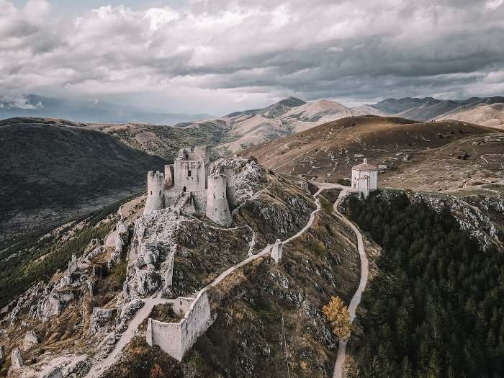

1. Tilt-Shift Photography - The “miniature effect” –

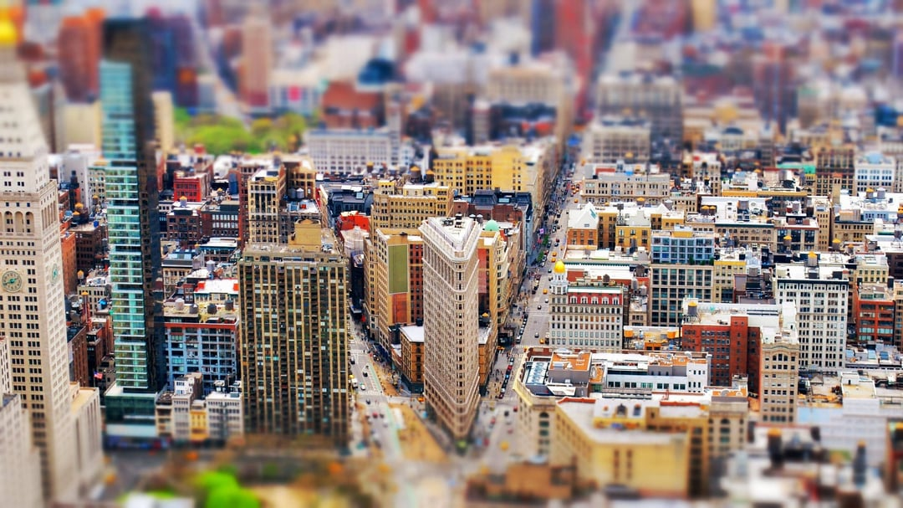

1. Pinhole Photography - using a pinhole or aperture instead of a lens.

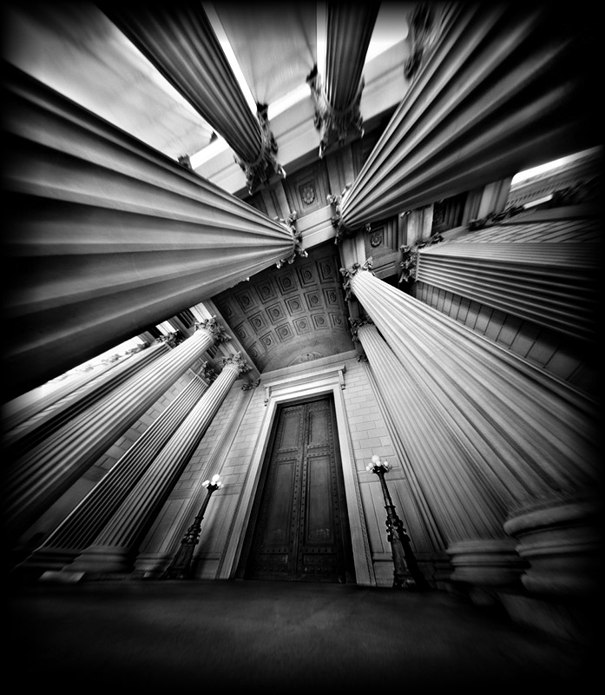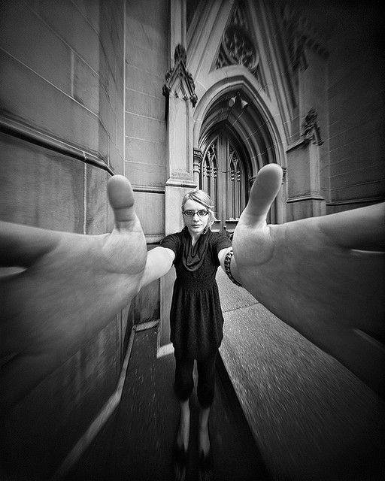

**2. People Photography**

1. Portrait Photography - capturing the personality of a person or group of people.



1. Self-Portrait Photography

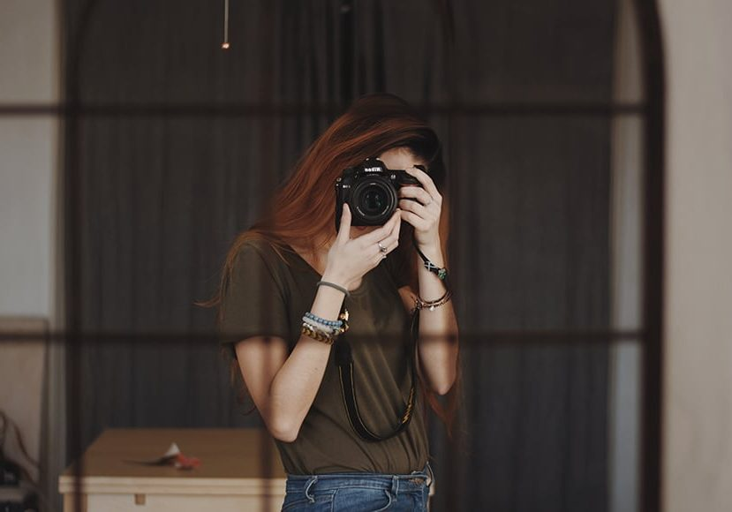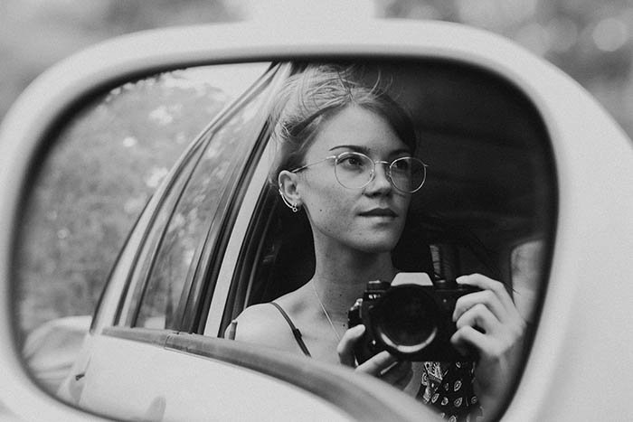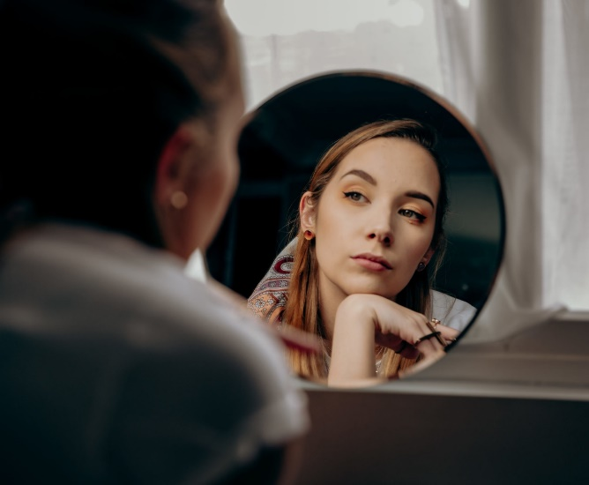

1. Wedding Photography
2. Sports Photography - the art of documenting sports, athletic activities, and athletes.

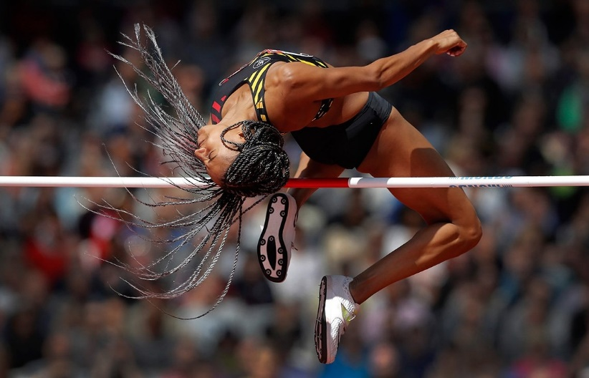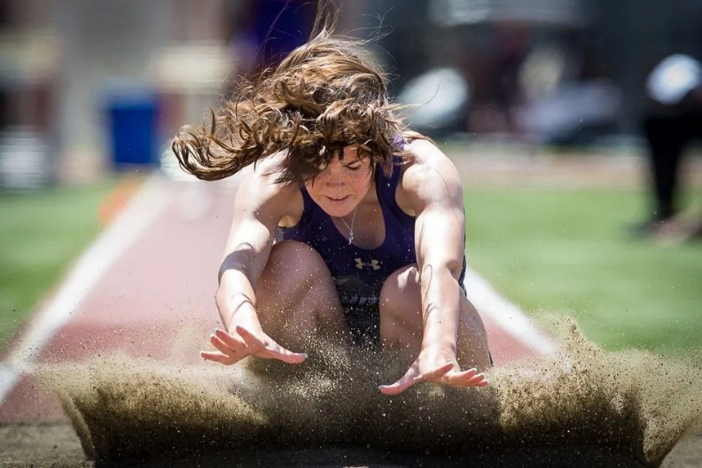

1. Music Photography or Concert Photography

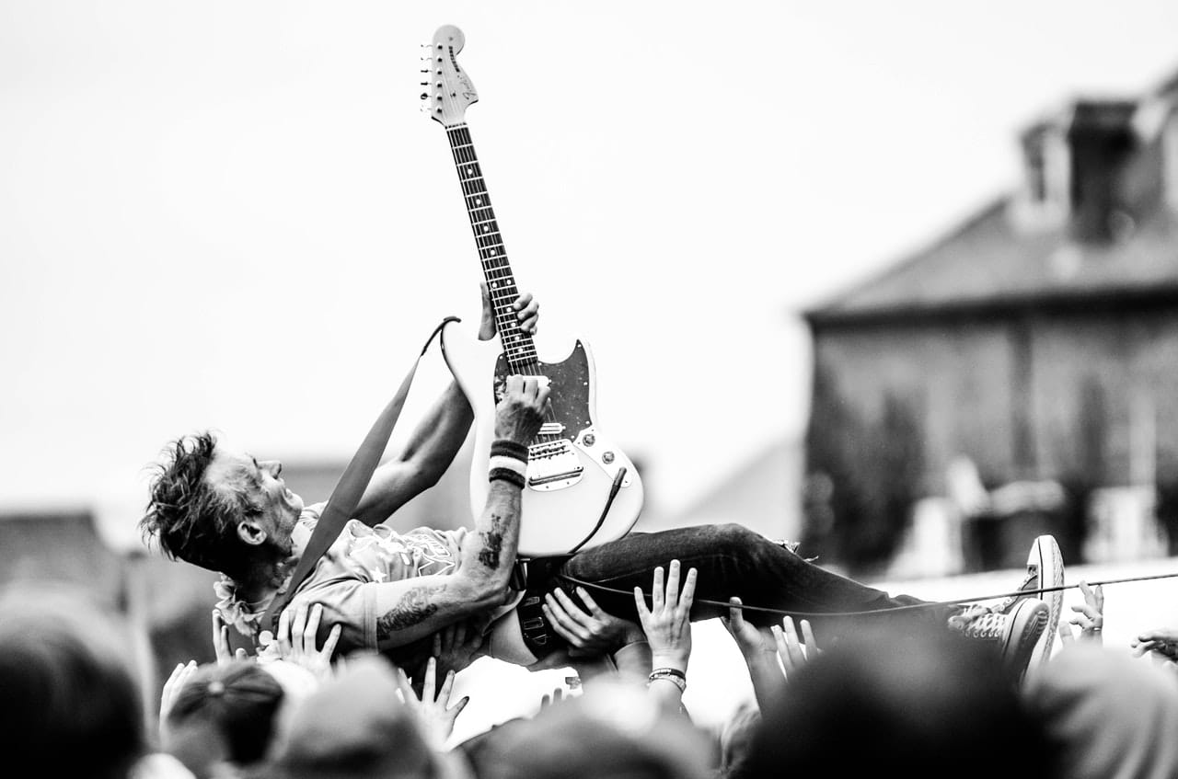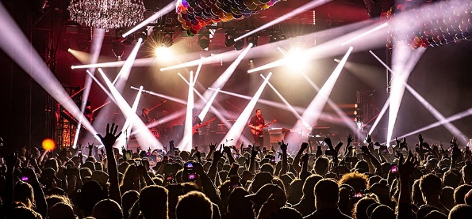

1. Event Photography - covers many different events, from music festivals to athletics championships.

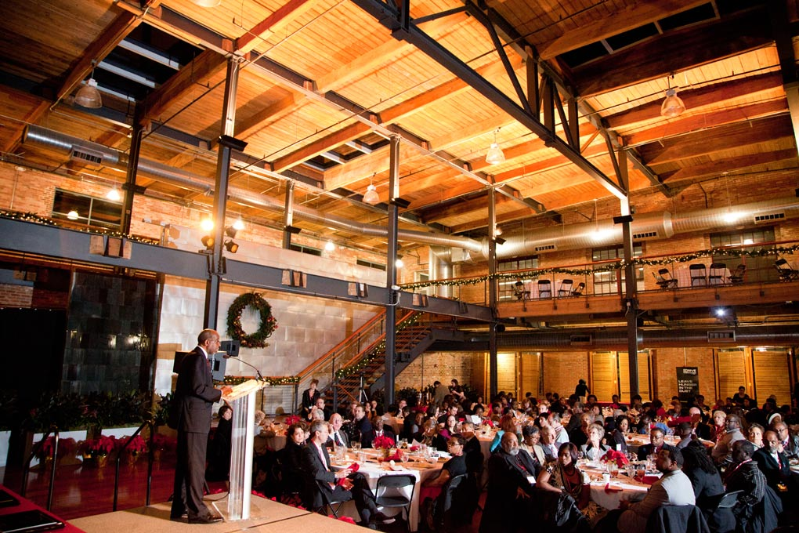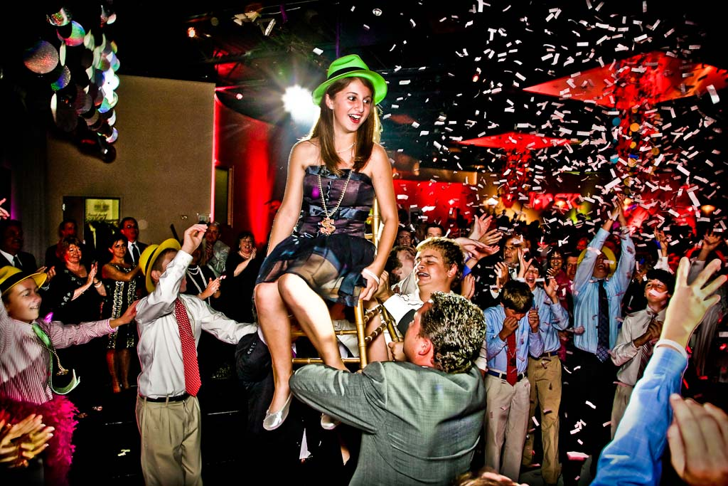

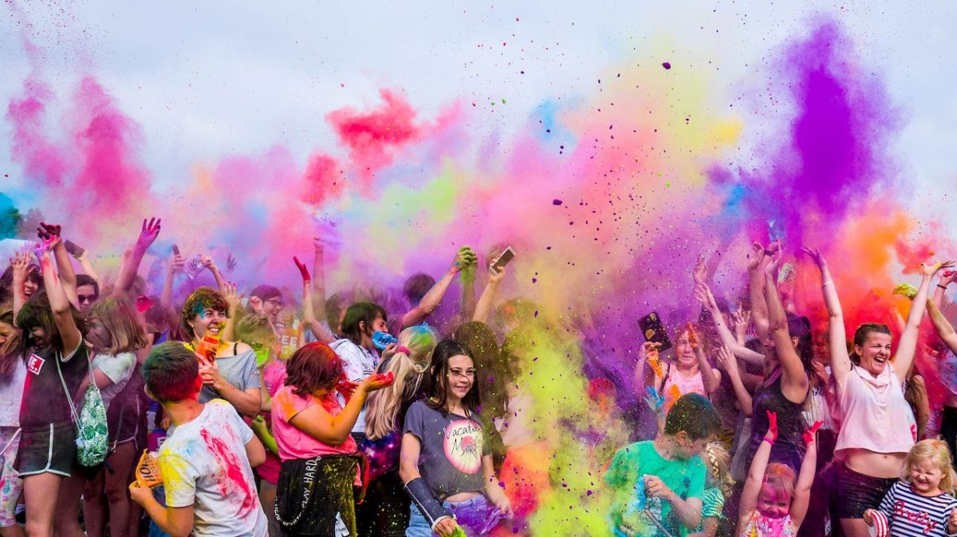

1. Fashion Photography - blend of portrait and product photography. portray a lifestyle.
2. Family Photography - Treasure moments with the ones they love. portraits or candid shots in a special location.
3. Child Photography
4. Newborn Photography
5. Headshot Photography - Headshot photography does have a lot in common with portrait photography. But headshots are specifically for professional purposes.



1. Boudoir Photography - This type of photography is for grown-ups. Boudoir photography is the art of taking sexy and sensual photos. But they don’t have to be explicit. Boudoir often includes lingerie, so there’s a crossover between fashion and product photography. Boudoir photography is about making the subject look and feel sexy, no matter who they are.

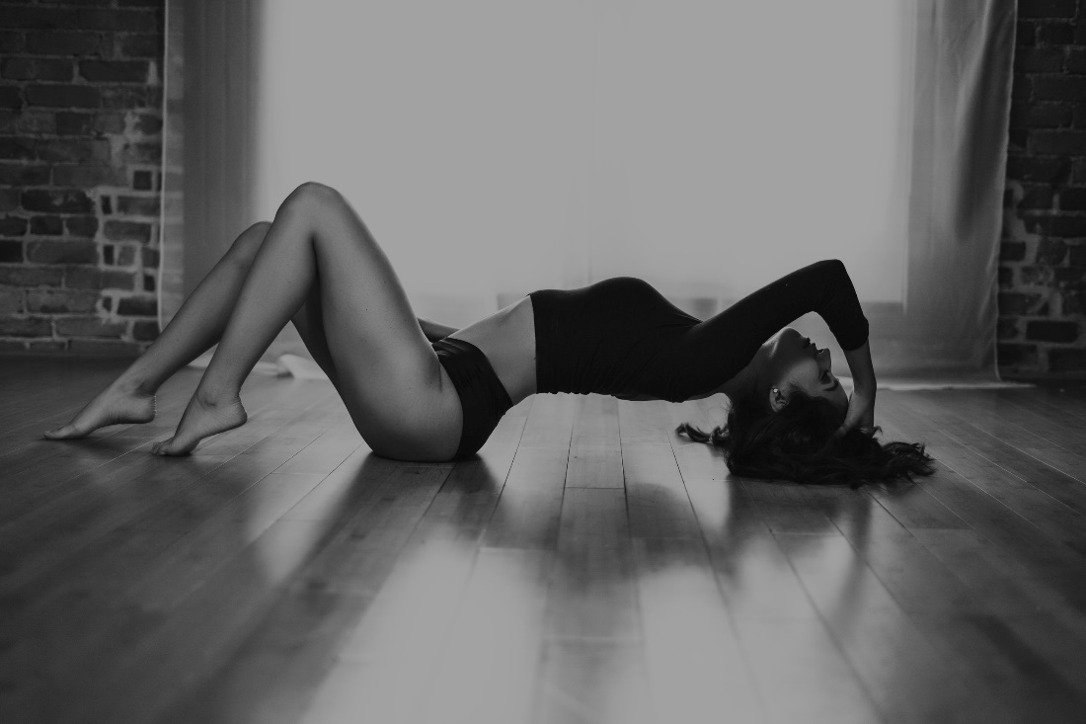

1. Glamor Photography - Glamor photography is more explicit than boudoir. It’s also sexy and sensual but leaves less to the imagination. It usually involves female models. And the main aim is sex appeal.

**3. Nature Photography**

1. Landscape Photography - Landscape photography is the study of the textured surface of the Earth. And it features images of natural scenes from all over the globe. Landscape photos can capture deserts, Rocky Mountains, or lush hillsides. They can be grand or more intimate images.

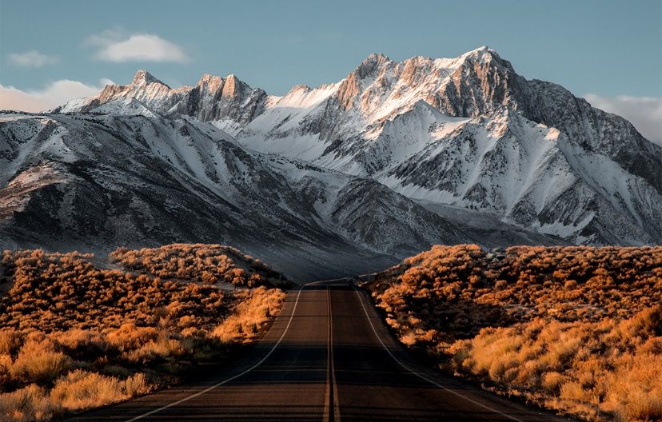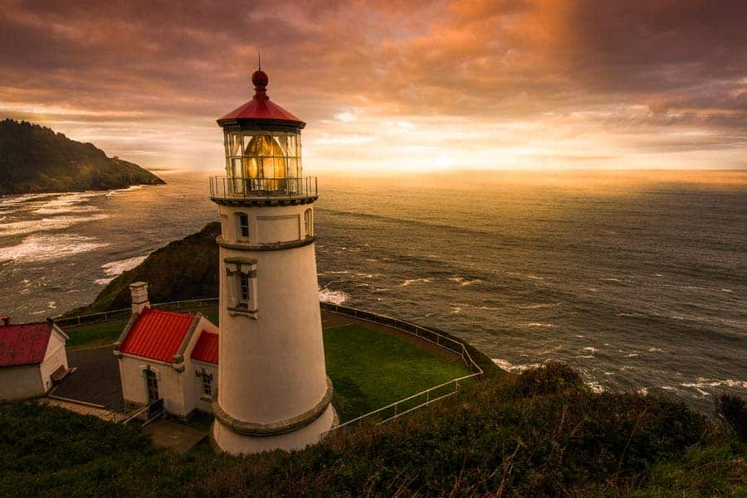

1. Wildlife Photography

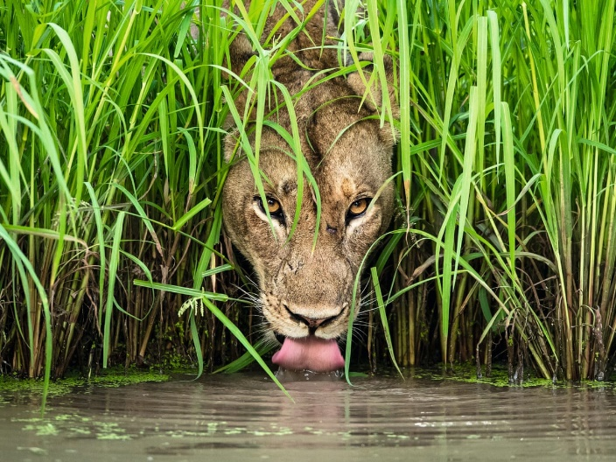

1. Bird Photography
2. Pet Photography
3. Macro Photography

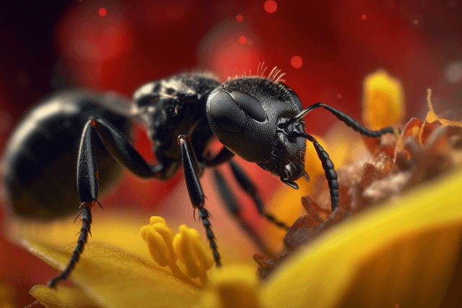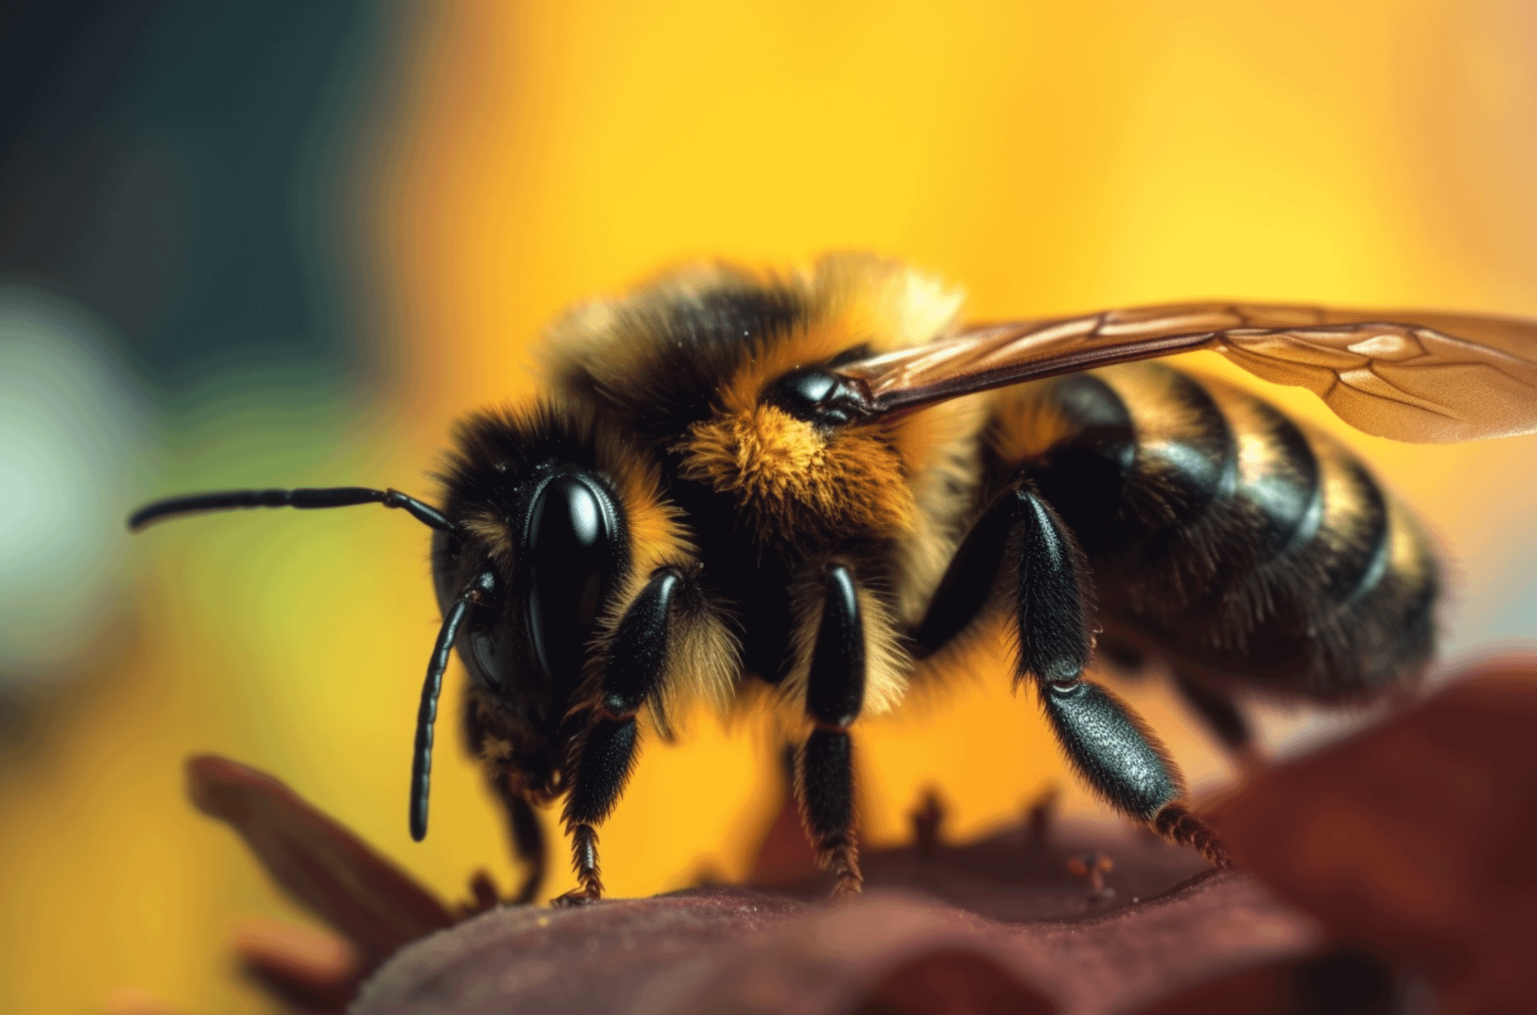

1. Sunset Photography

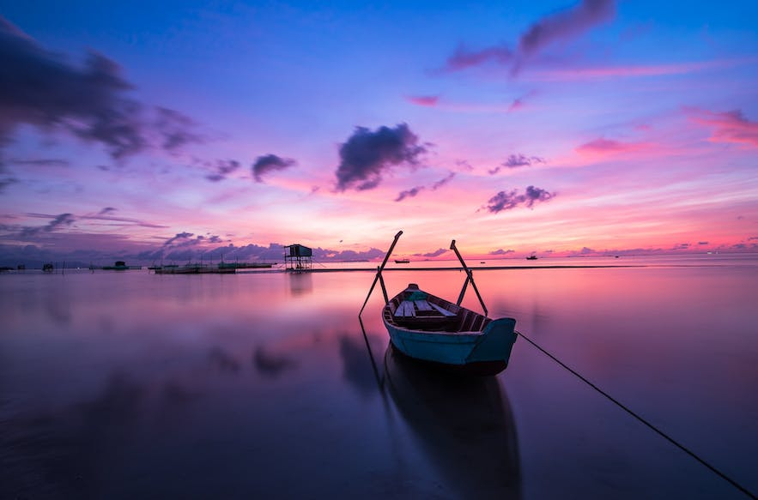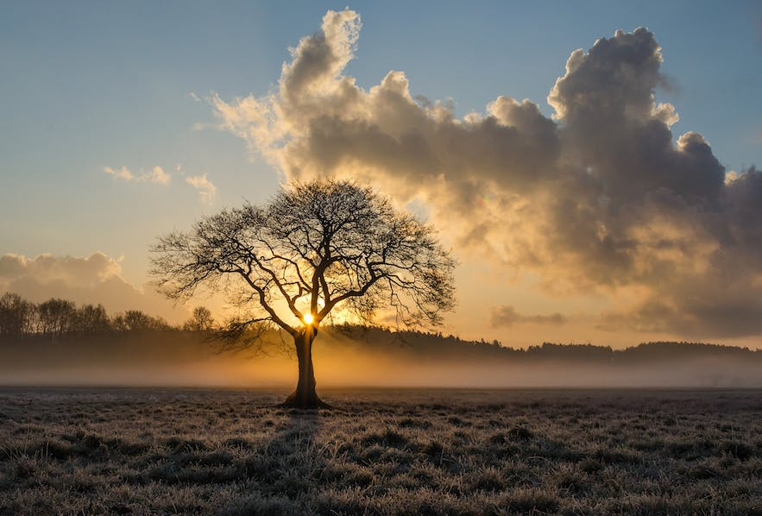

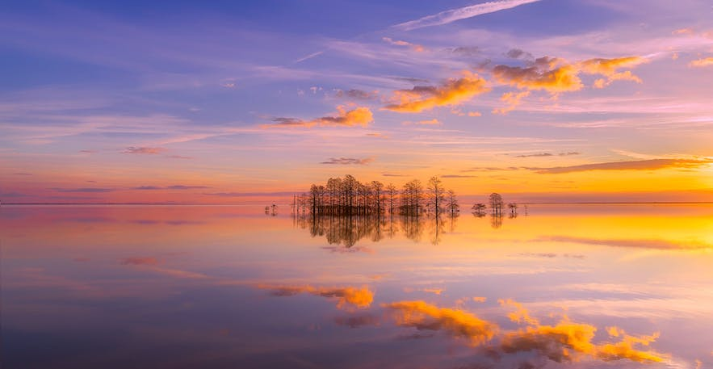

1. Ocean Photography

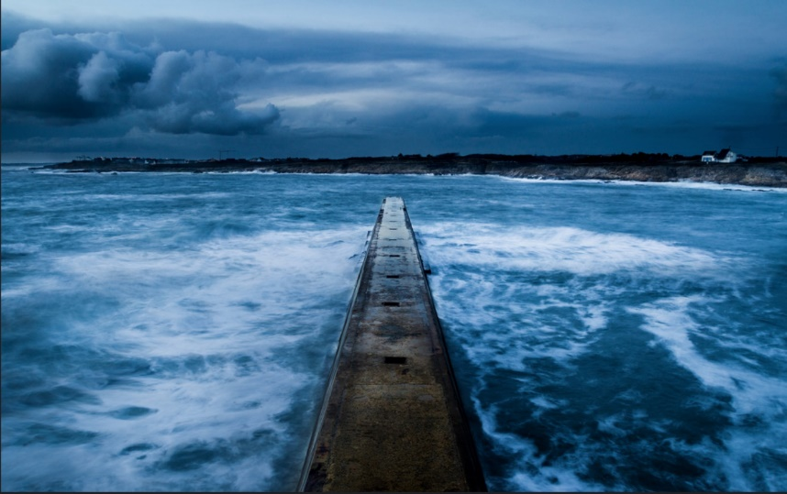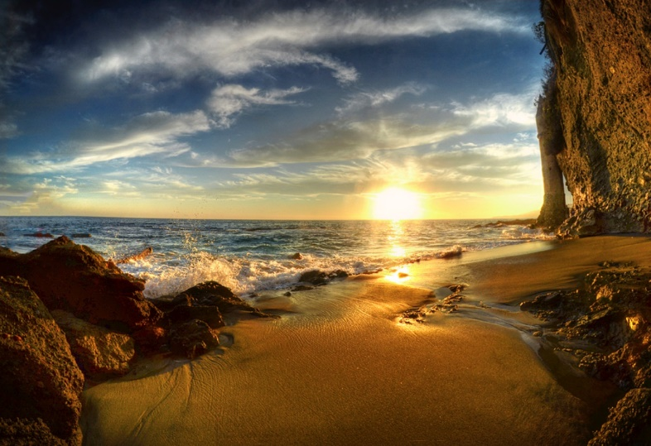

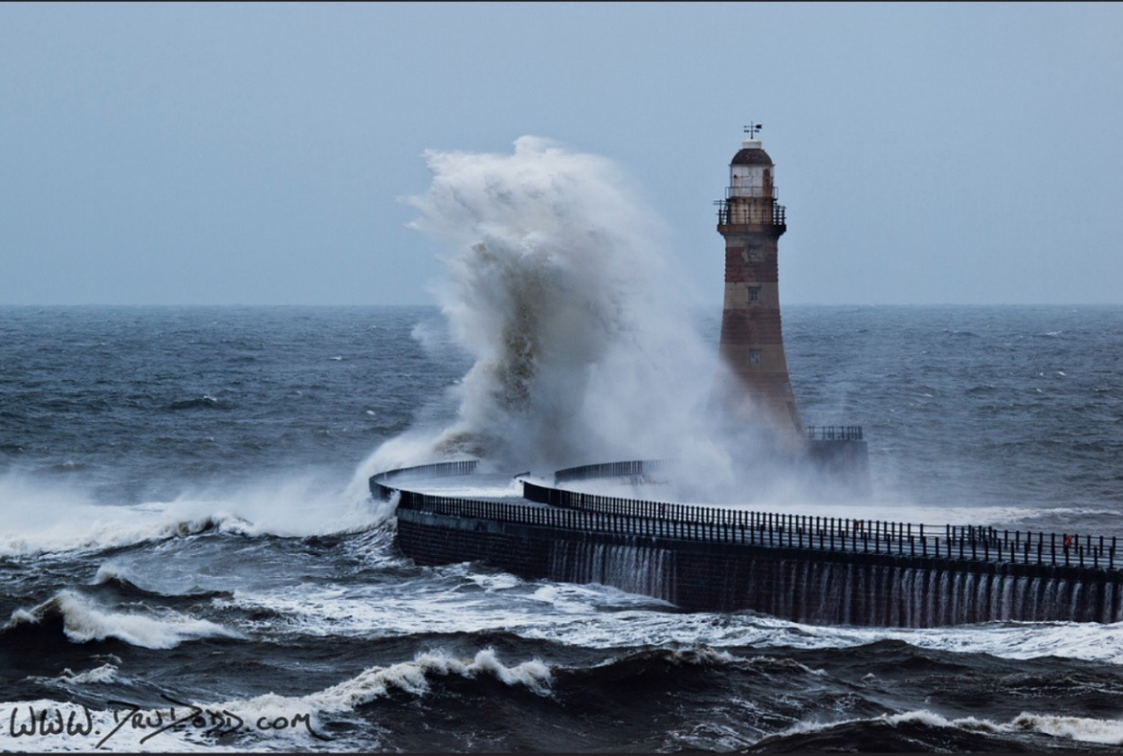

1. Underwater Photography

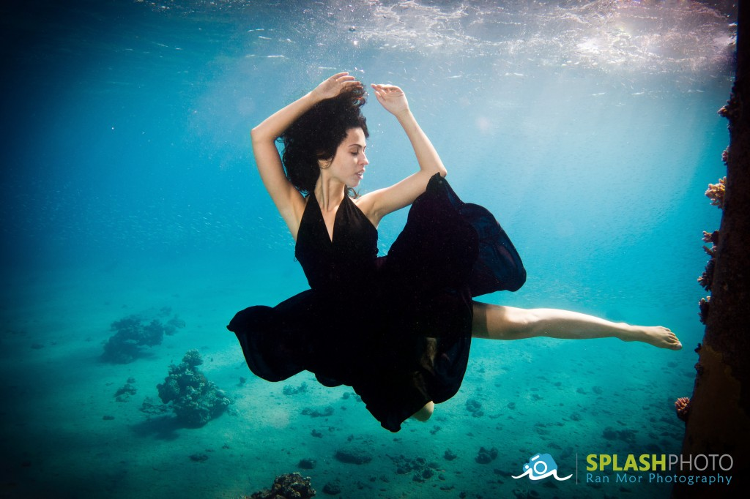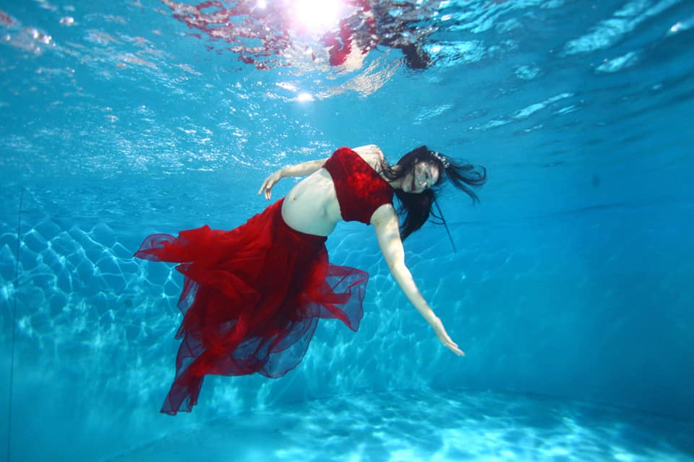

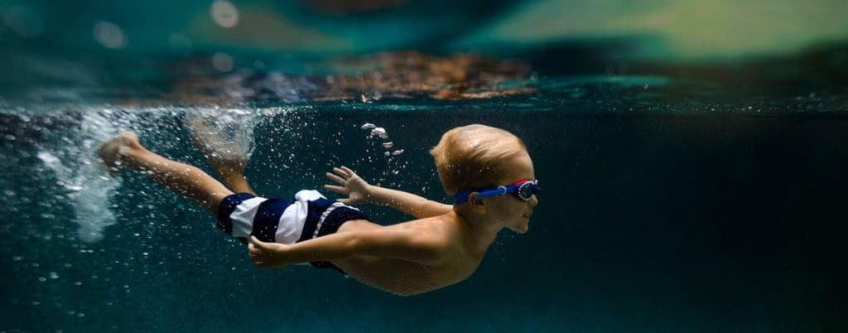

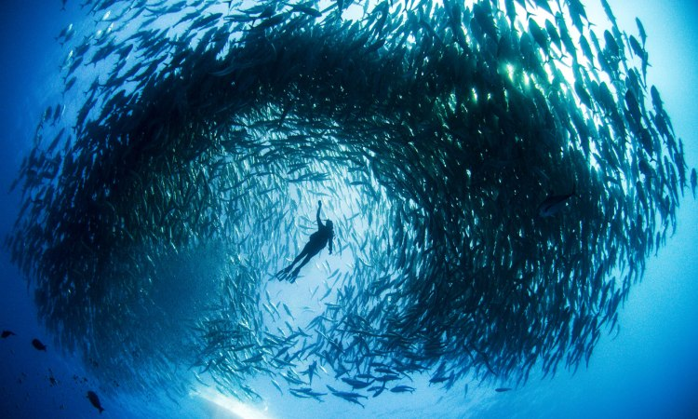

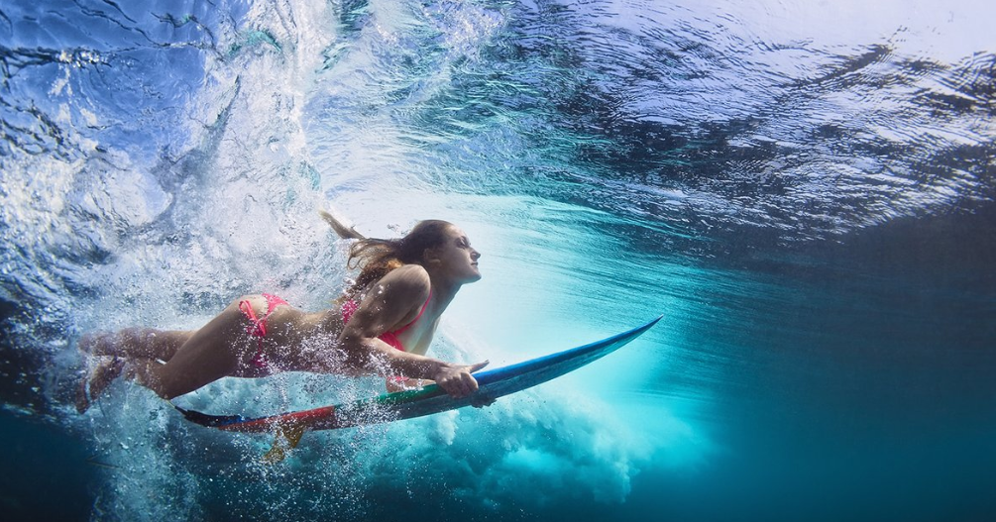

1. Cityscape Photography - longer exposure (on a tripod or sturdy base for 30 seconds+) at a low ISO instead. Cityscape photography is a form of landscape photography, but the landscapes in question are elements of a city. Often, these photos are shot with the goal of capturing the skyline of the city.

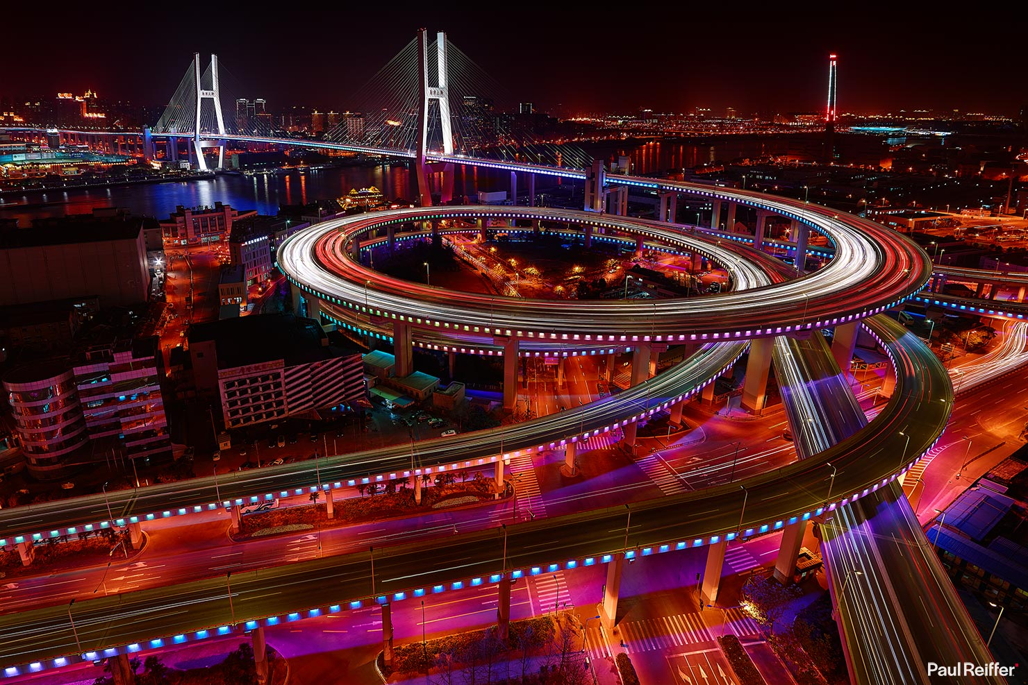

1. Aerial Photography - Aerial photography typically uses a digital camera, while drone mapping uses photographic cameras that have a fish-eye lens.

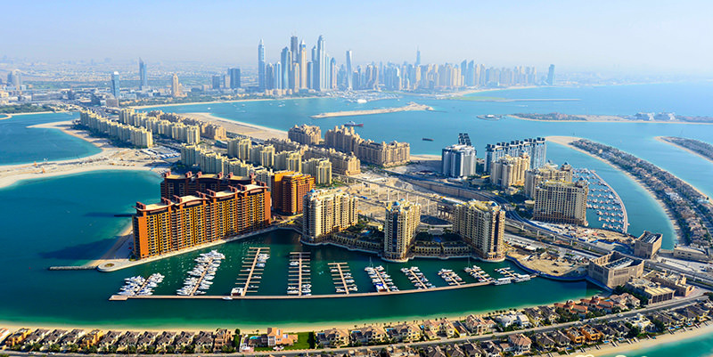

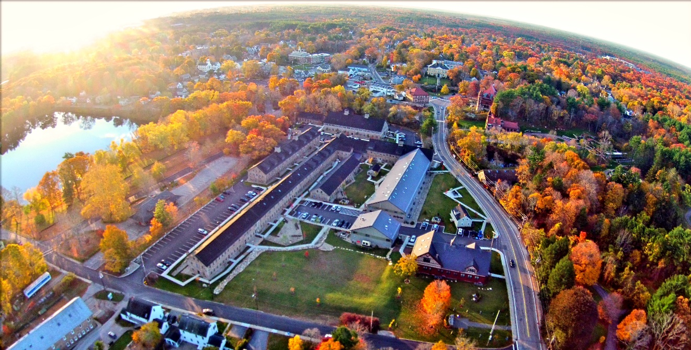

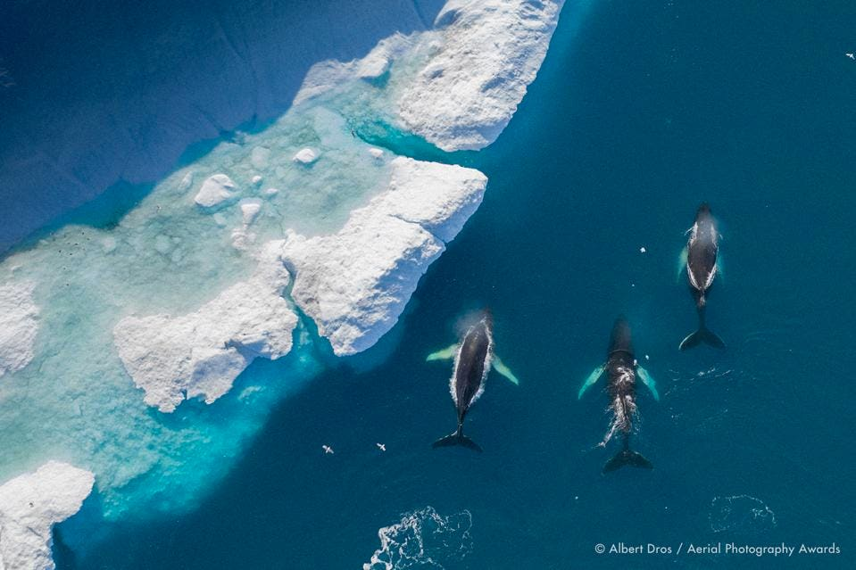

1. Astrophotography - known as astronomical imaging, is the photography or imaging of astronomical objects, celestial events, or areas of the night sky.

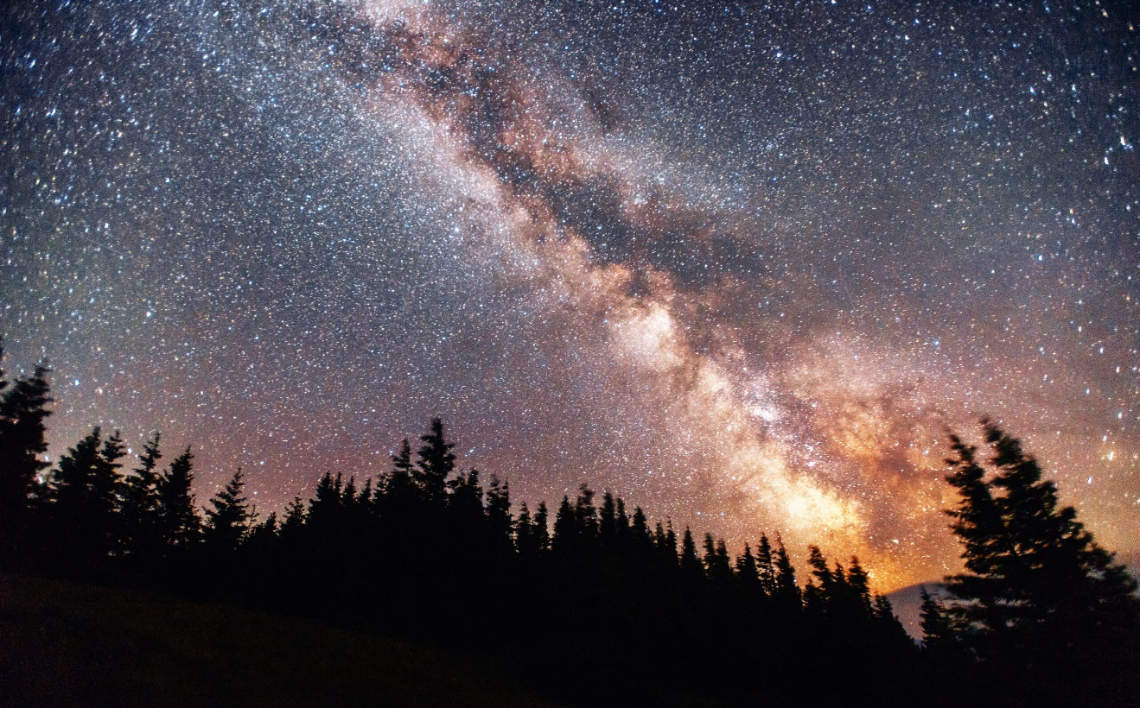

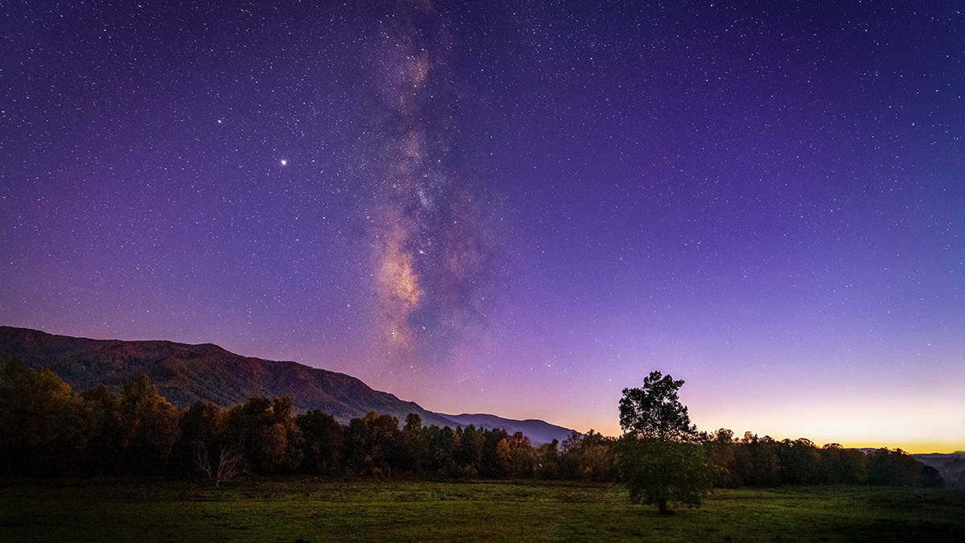

1. Panorama Photography - Panorama photography is a branch of landscape photography. But it extends the frame’s limits, creating an ultra-wide-angle view of the scene.

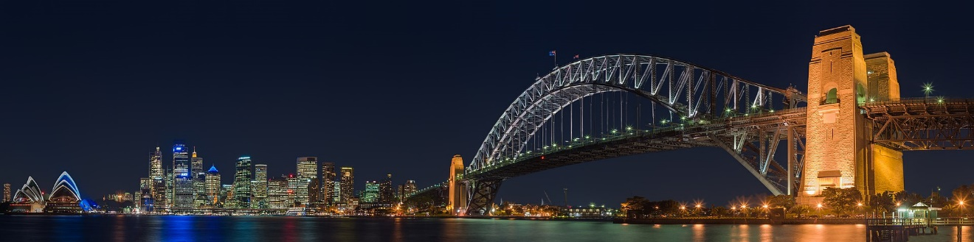

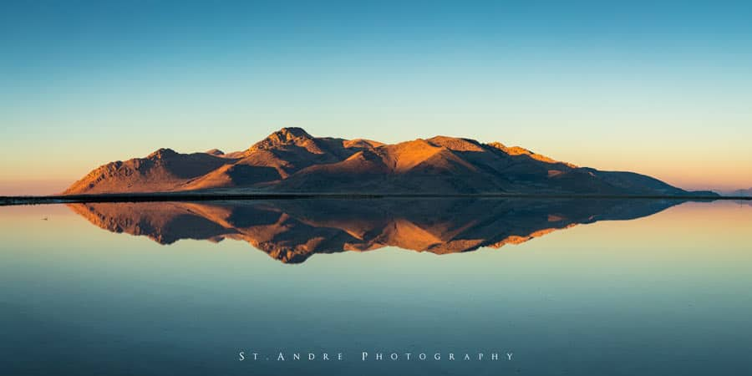

**4. Reportage Photography**

1. Photojournalism - Photojournalism is the communication of news through photographs. These images tend to appear in print newspapers and magazines as well as online media sites and microblogging platforms.

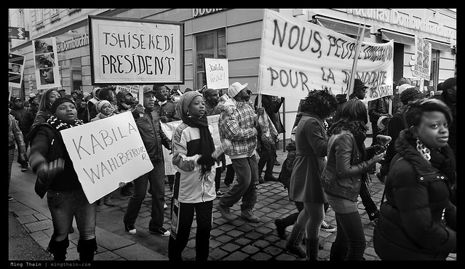

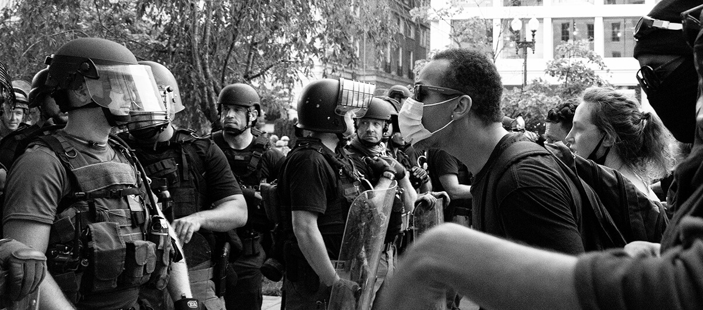

1. Documentary Photography - Documentary photography describes any photos that attempt to record the world as it is. From wide-angle photographs of war to close-up snapshots of people on the street, these images can inform an audience about the hidden corners of contemporary life and even become part of the historical record.

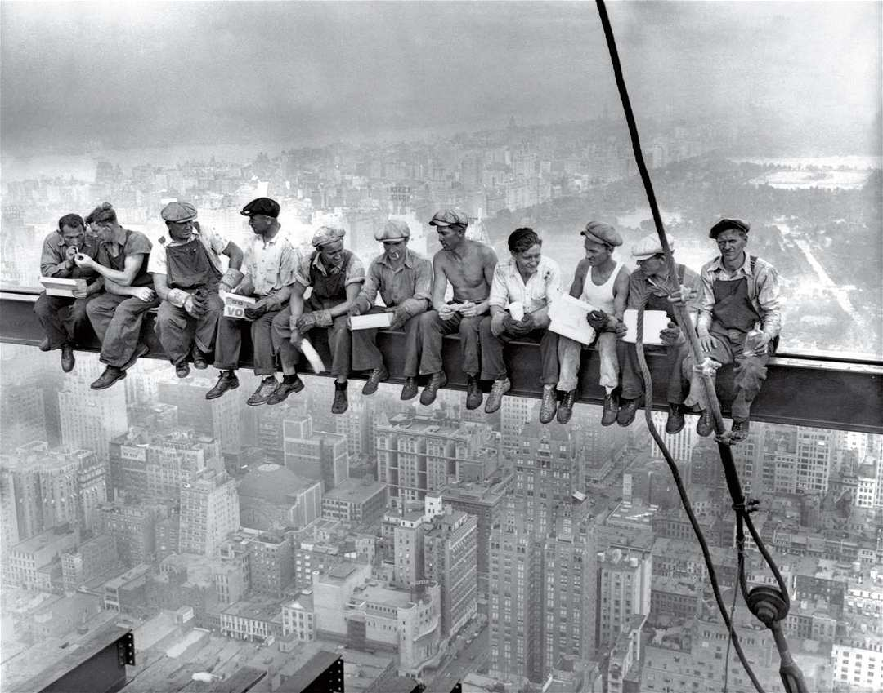

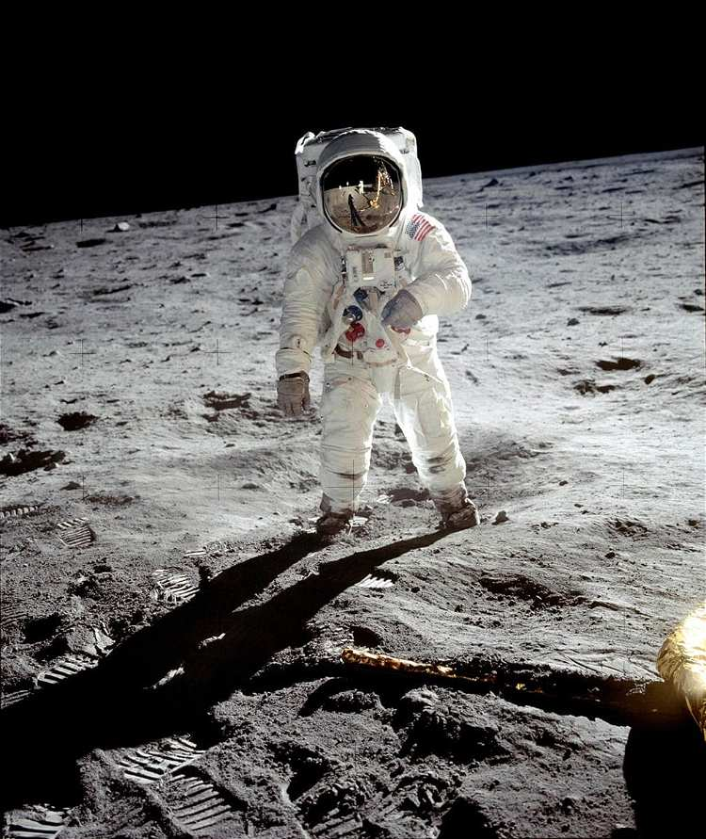

1. Street Photography - Street photography is photography conducted for art or inquiry that features unmediated chance encounters and random incidents within public places, usually with the aim of capturing images at a decisive or poignant moment by careful framing and timing.

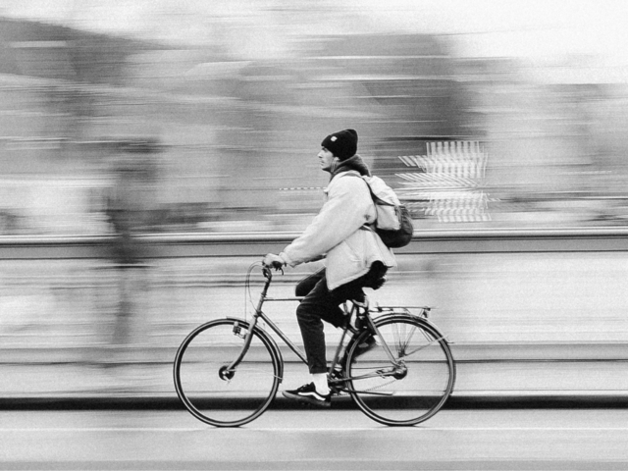

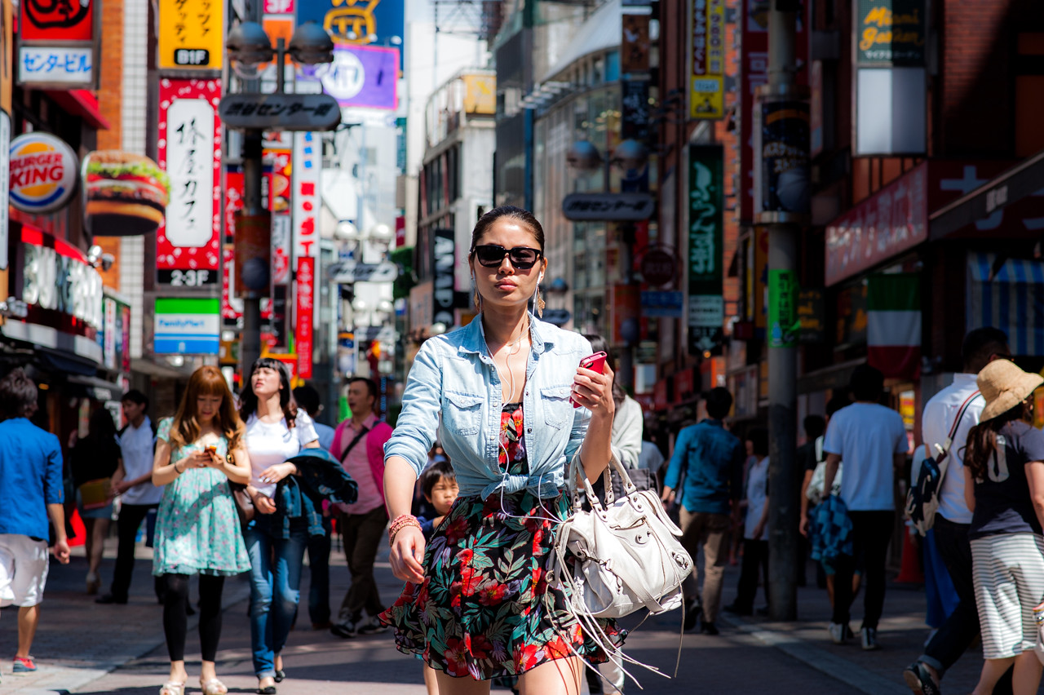

1. Travel Photography - Travel photography is a genre of photography that may involve the documentation of an area's landscape, people, cultures, customs, and history.

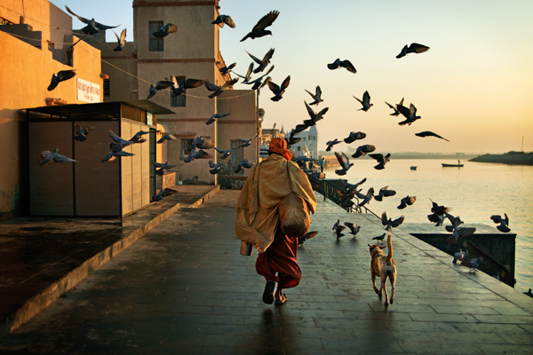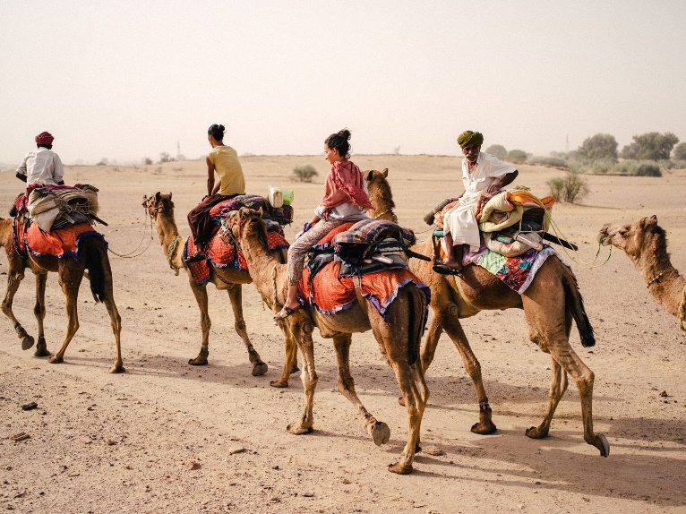

1. Urban Exploration Photography or Urbex - Urban exploration, or “urbex,” takes you to abandoned places. You venture into old factories and derelict buildings with a camera around your neck. These places litter our urban landscapes, though many are long forgotten.

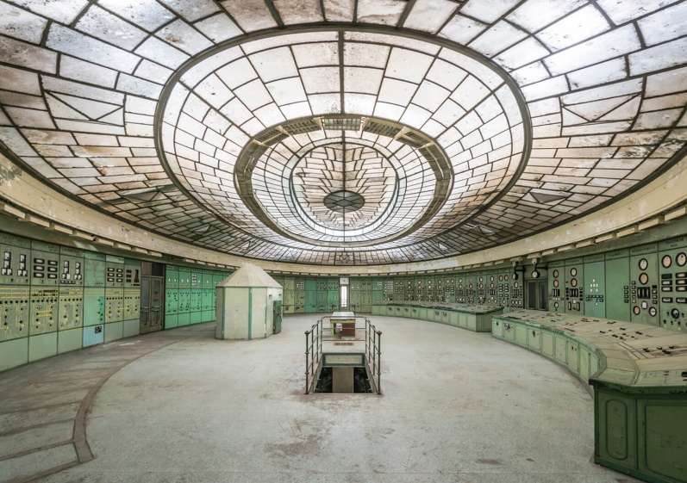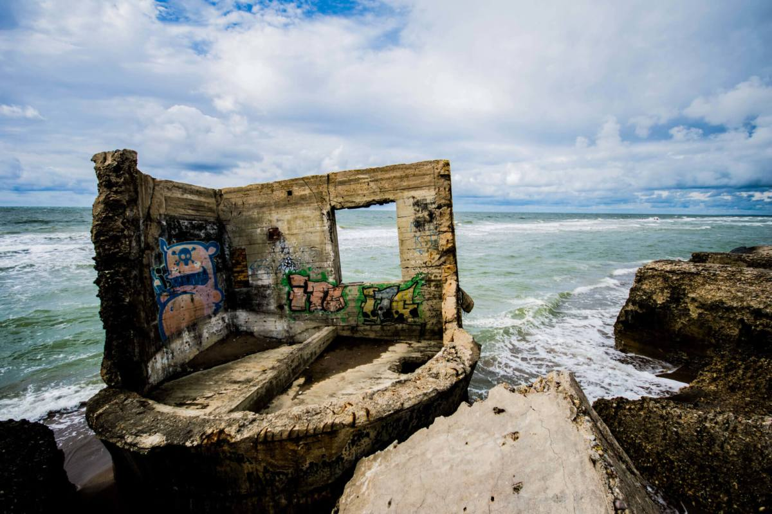

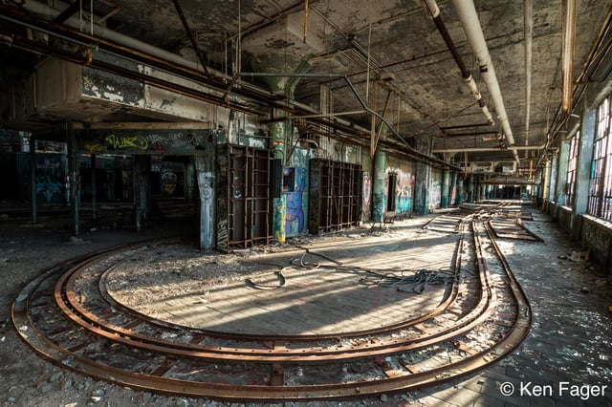

1. Editorial Photography - Editorial photography is images that appear alongside the text in print or online publications, which are created to help tell a story or support the narrative in the text, with a focus on creating a specific mood or tone for the piece.

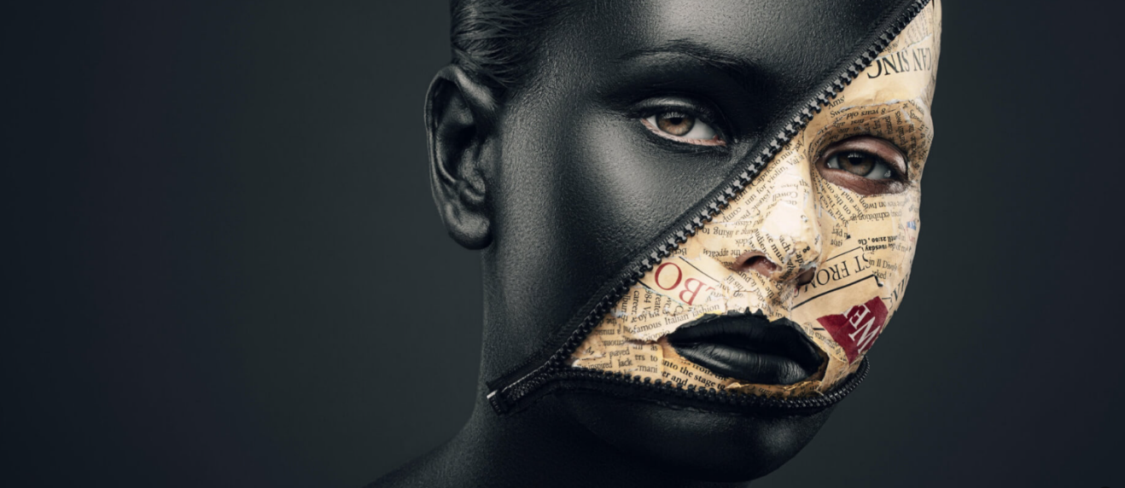



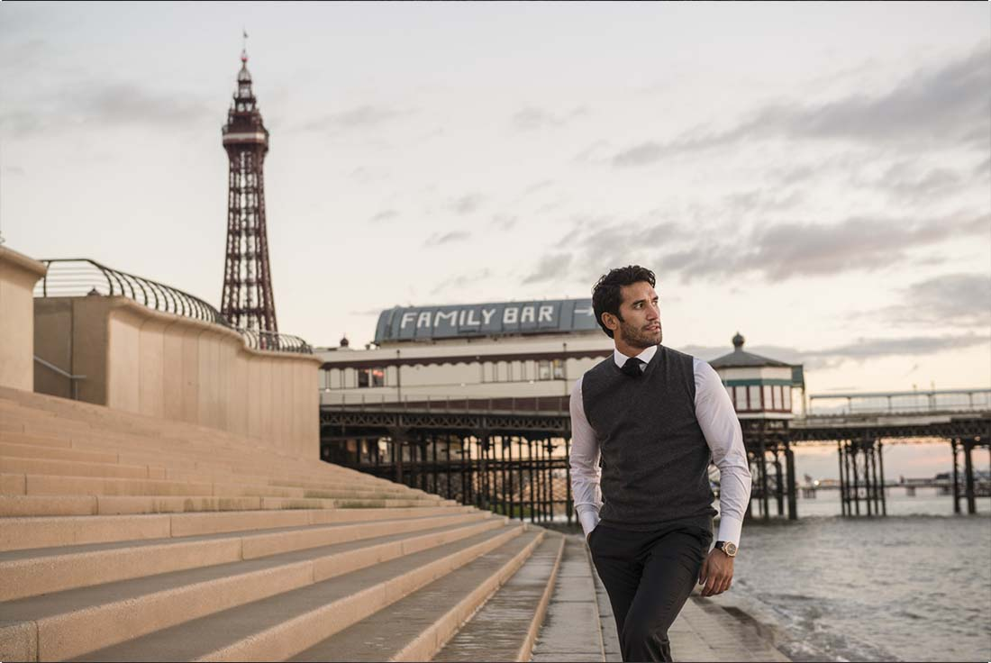

1. War Photography - War photography involves photographing armed conflict and its effects on people and places.

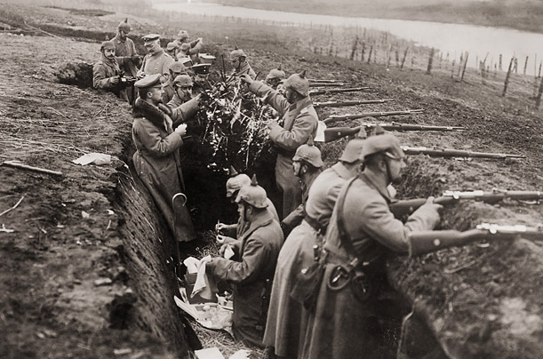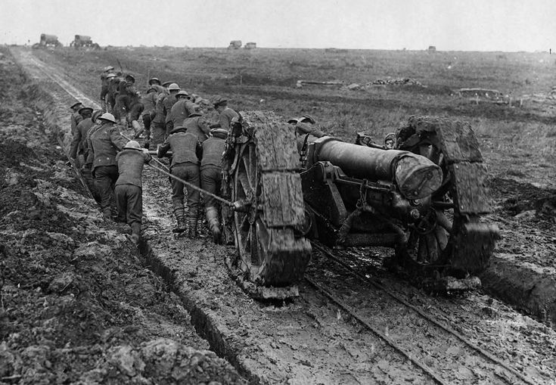

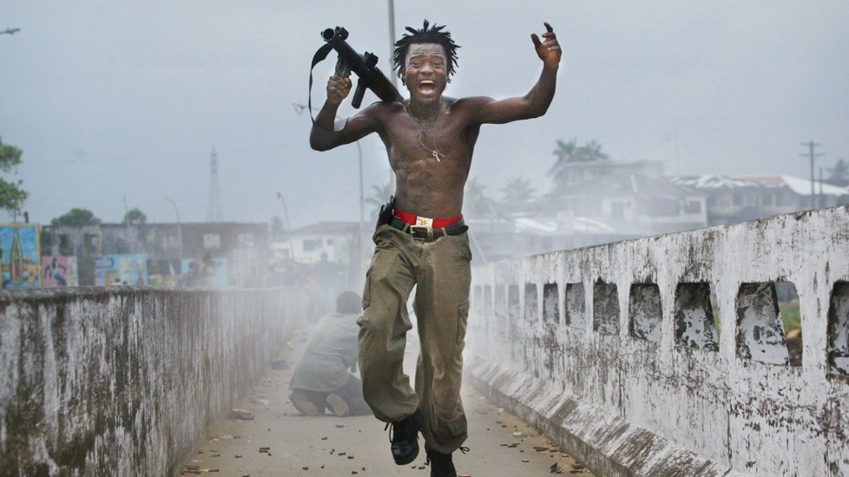

1. Action Photography - Action photography is about capturing subjects in motion. It can encompass wildlife and sports photography.

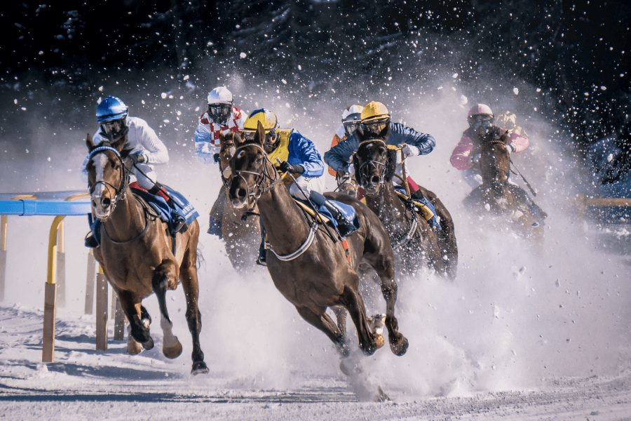 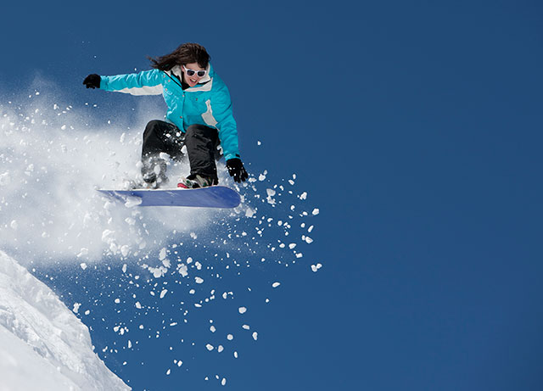

**5. Artistic Photography**

1. Fine Art Photography - Fine-art photography is photography created in line with the vision of the photographer as artist, using photography as a medium for creative expression. The goal of fine-art photography is to express an idea, a message, or an emotion.

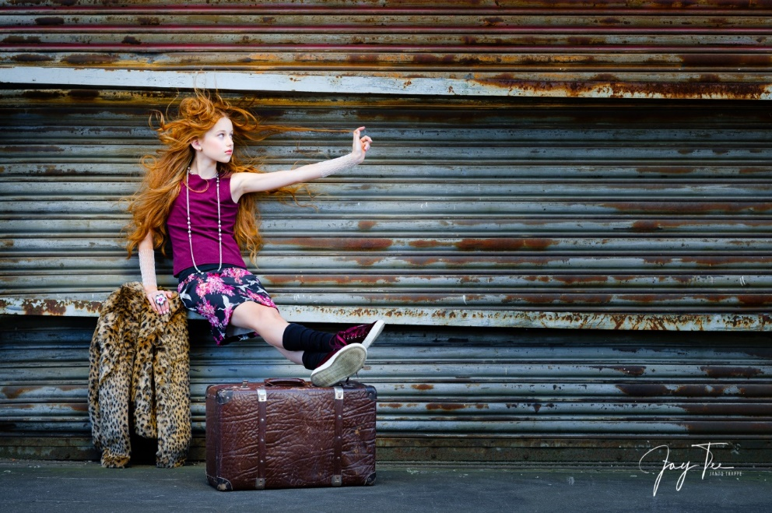

1. Still Life Photography - Still life photography is a genre of photography used for the depiction of inanimate (not alive) subject matter, typically a small group of objects. Tabletop photography, product photography, food photography, found object photography etc. are examples of still life photography.

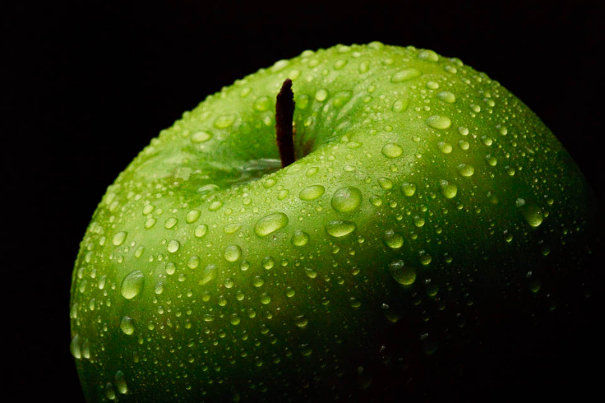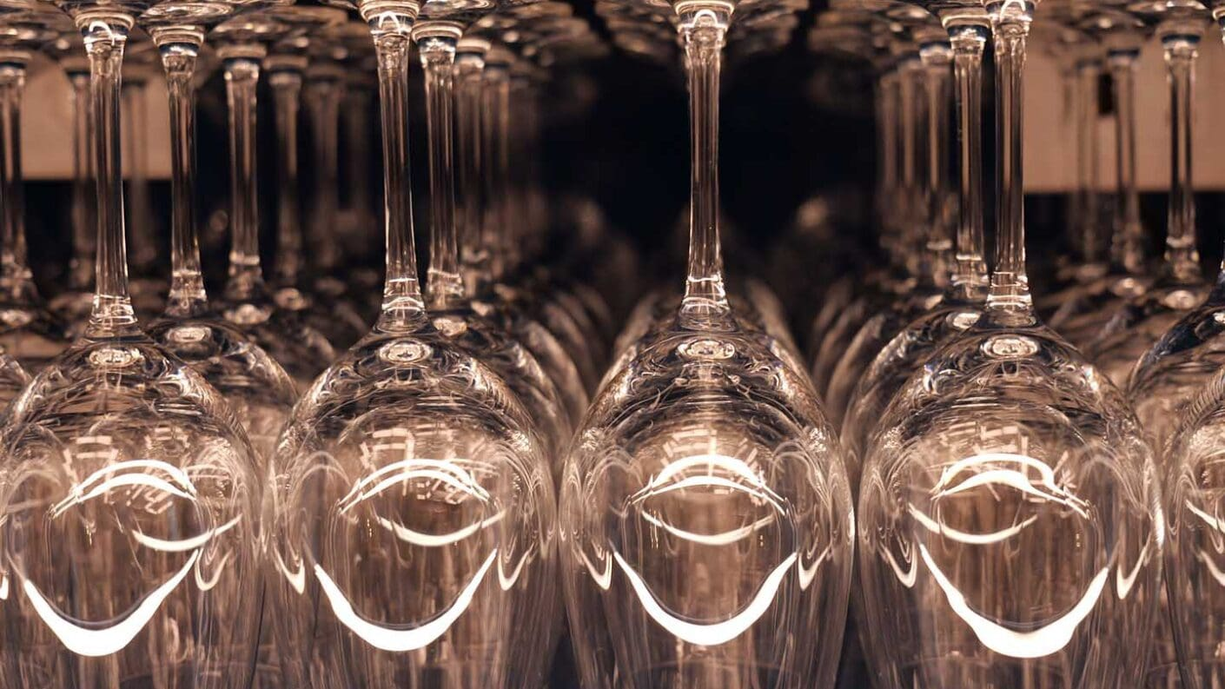



1. Abstract Photography - Abstract photography takes objects out of their normal context. It strips the subject of its meaning, so it’s nothing more than a form. Abstract photographers look for shapes and patterns in their environment. And they frame them in an aesthetically pleasing way.

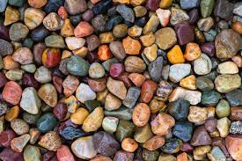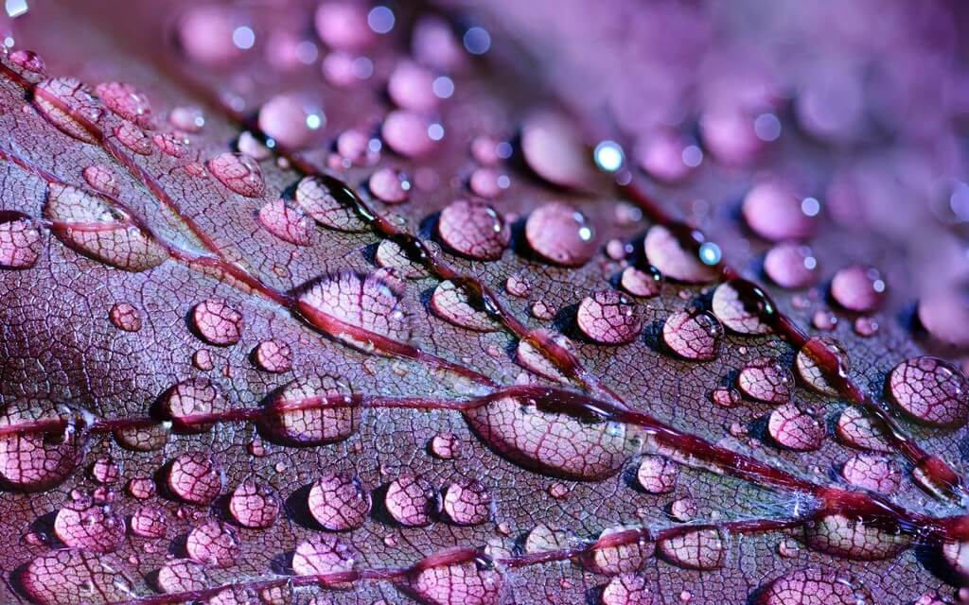

1. Minimalist Photography - Minimalist photography is about stripping a subject down to its most elegant essence. Create photos that cut through the clutter by emphasizing the essentials, including clean lines and empty spaces.

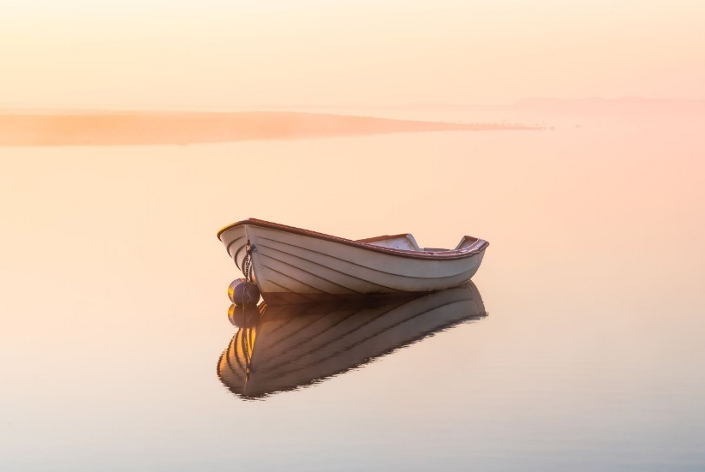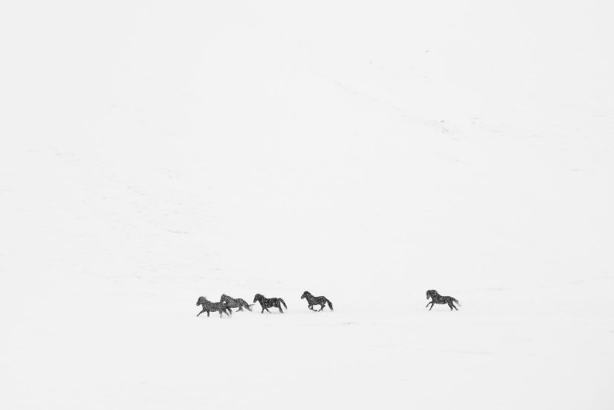

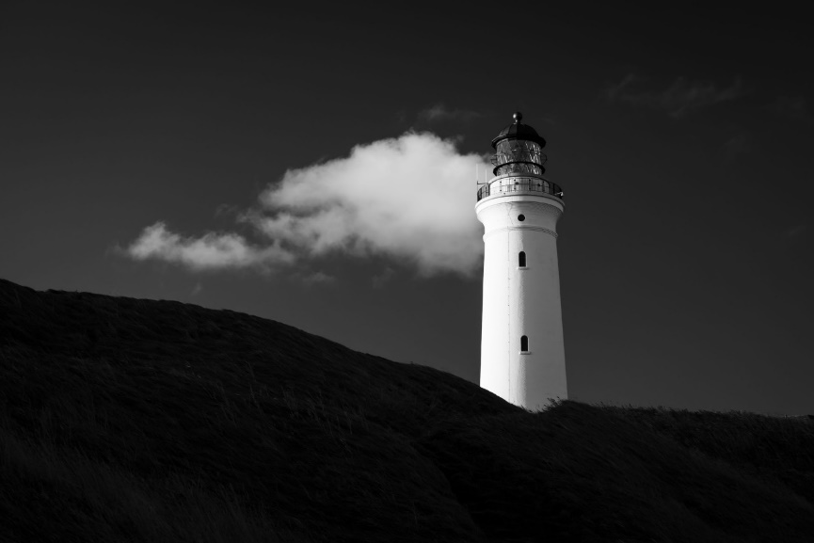

1. Fantasy Photography - This genre is about creating worlds and characters and using them to tell stories with your photos.

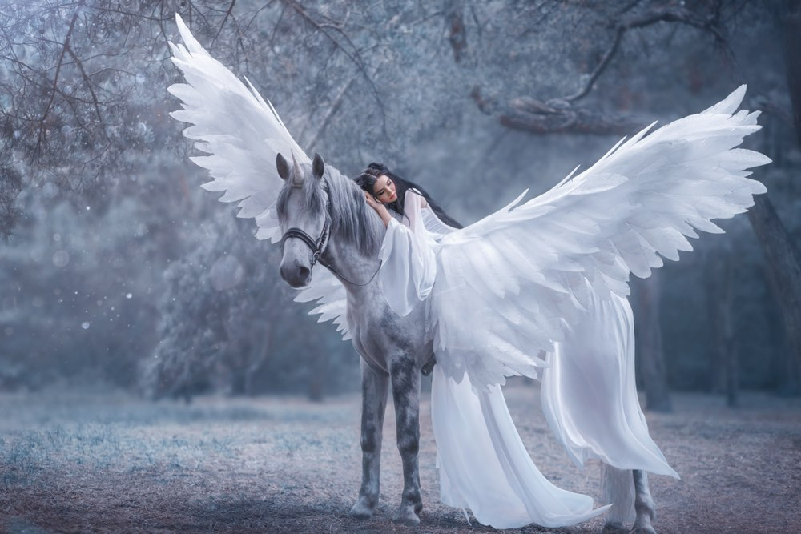

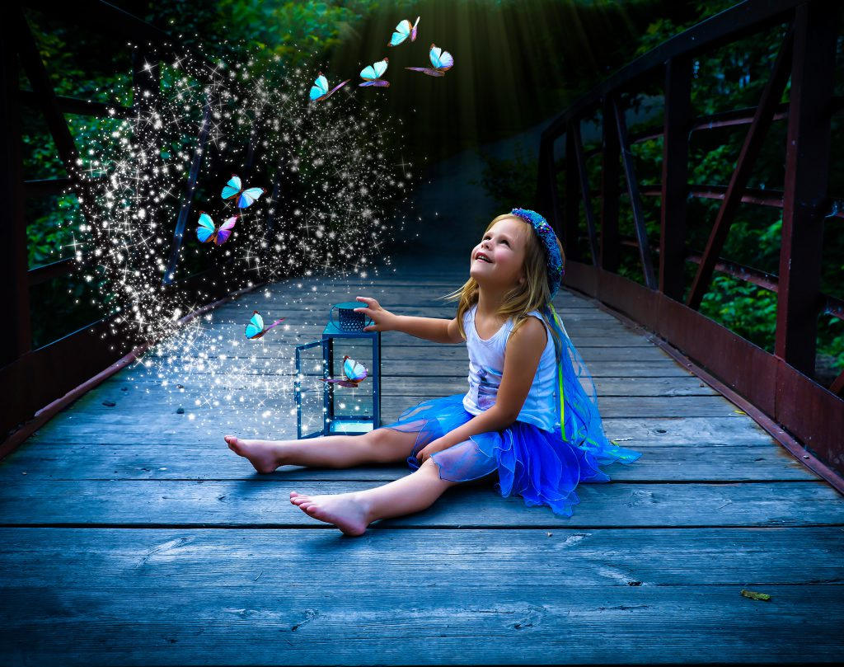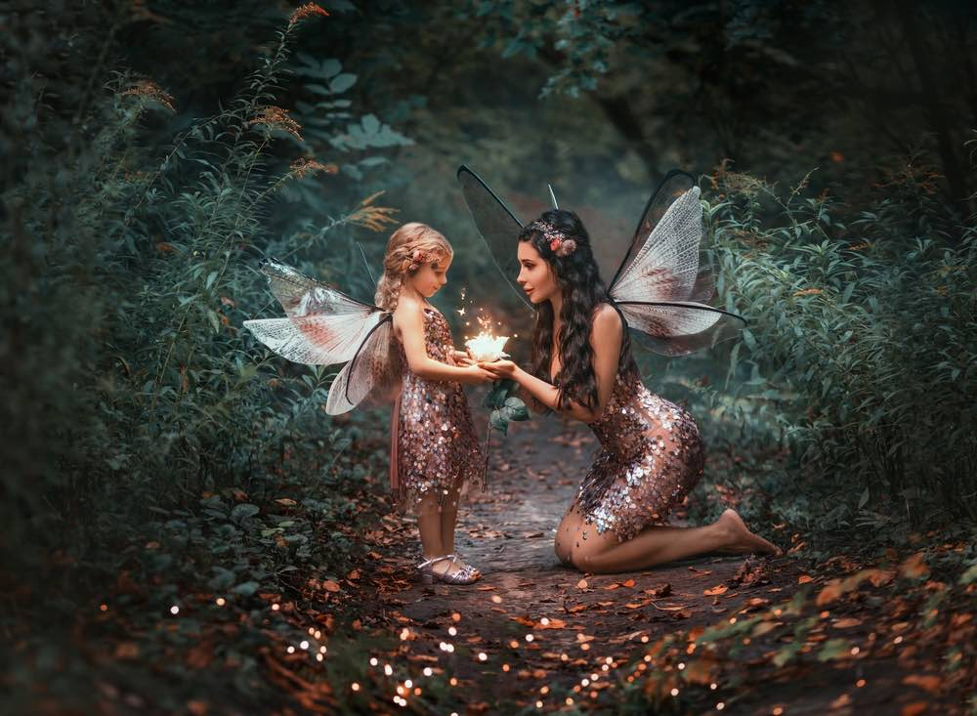

1. 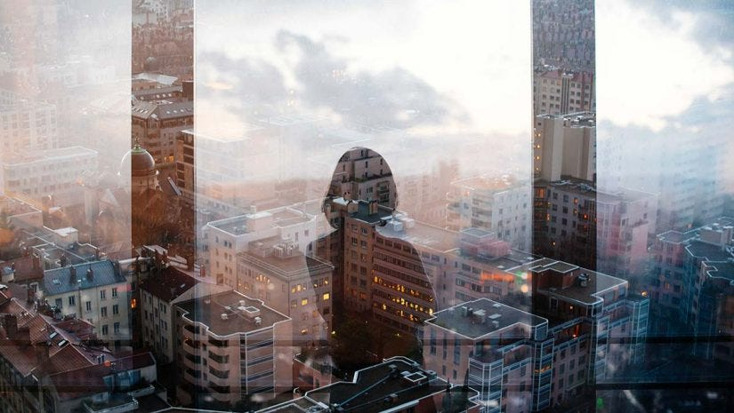Multiple Exposure Photography - In photography and cinematography, multiple exposure is a technique in which the camera shutter is opened more than once to expose the film multiple times, usually to different images. The resulting image contains the subsequent image/s superimposed over the original.

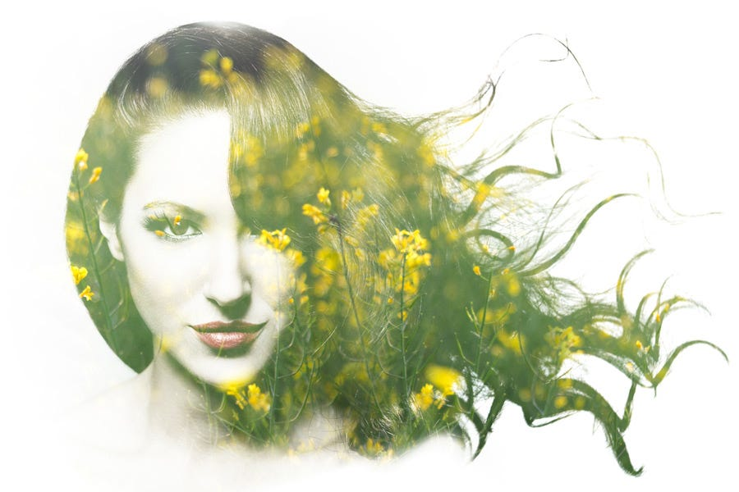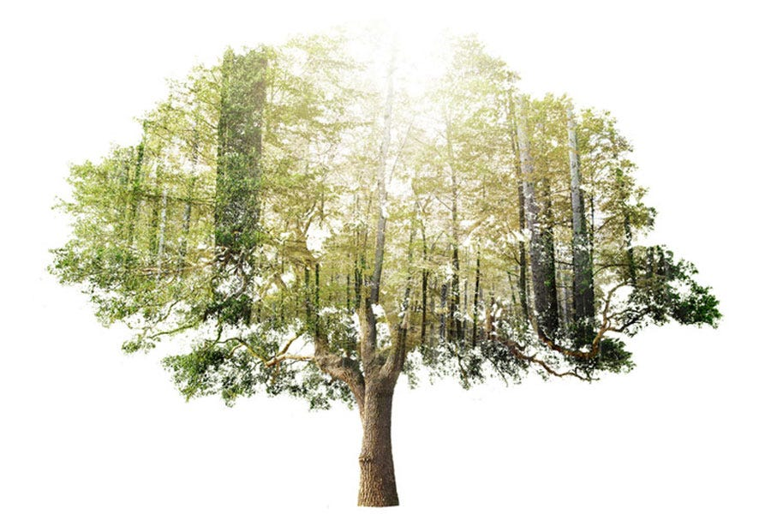

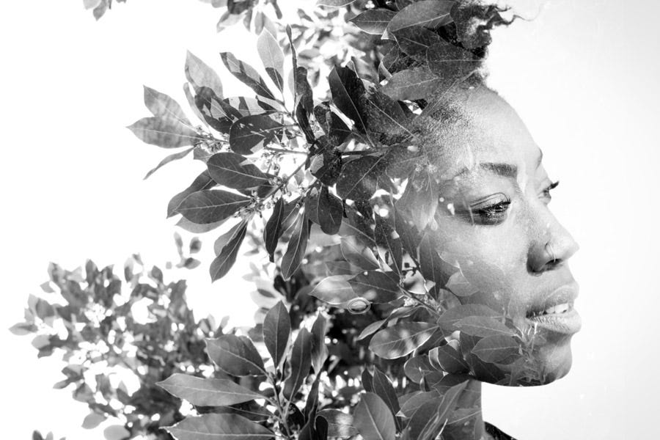

1. Composite Photography - a photograph made by combining several distinct photographs either made one over another on the same plate or made on one print from a number of negatives.

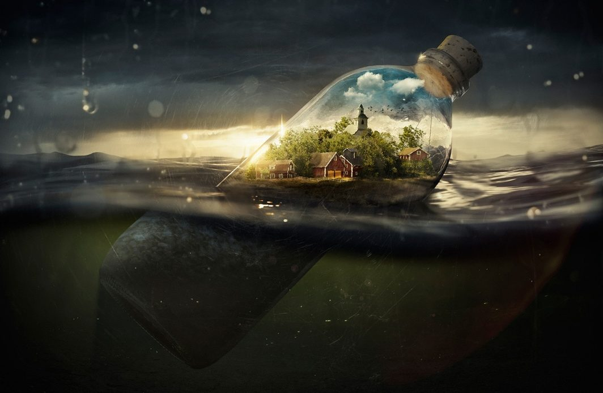

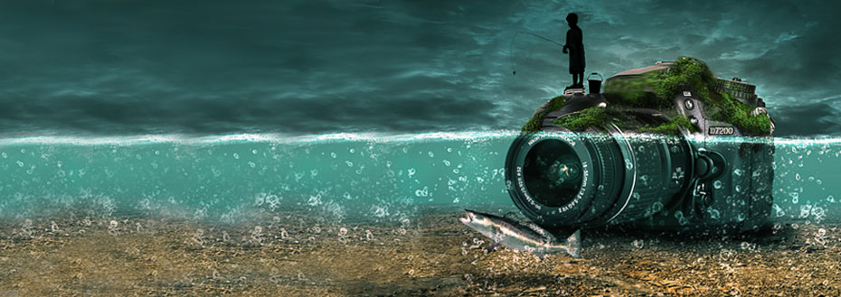

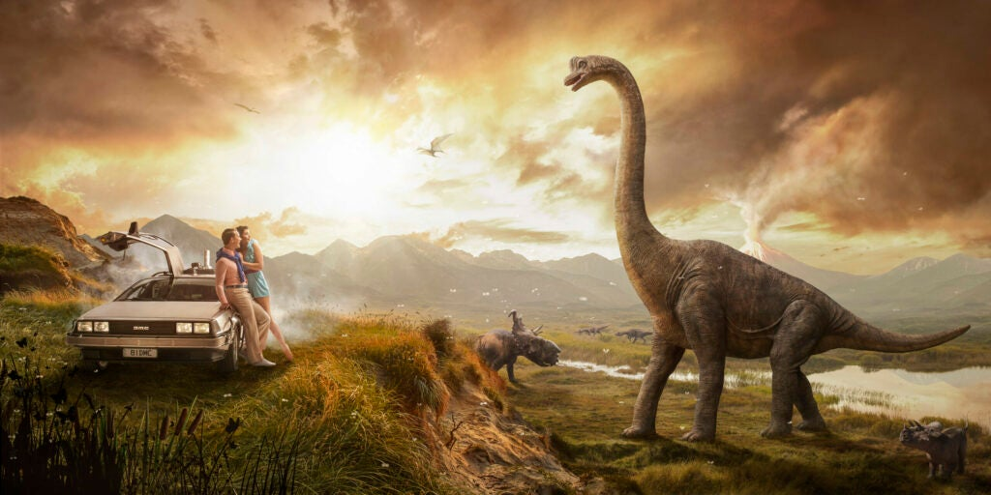

1. Time-Lapse Photography
2. Long-Exposure Photography - Long-exposure, time-exposure, or slow-shutter photography involves using a long-duration shutter speed to sharply capture the stationary elements of images while blurring, smearing, or obscuring the moving elements.

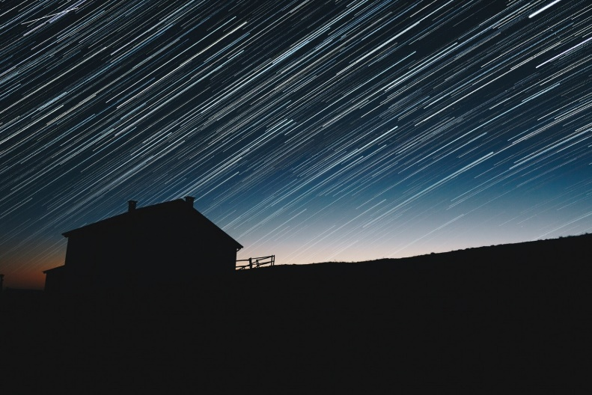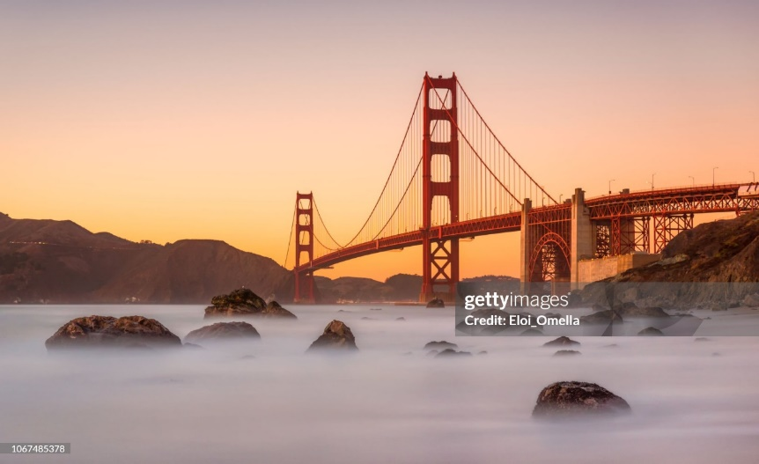

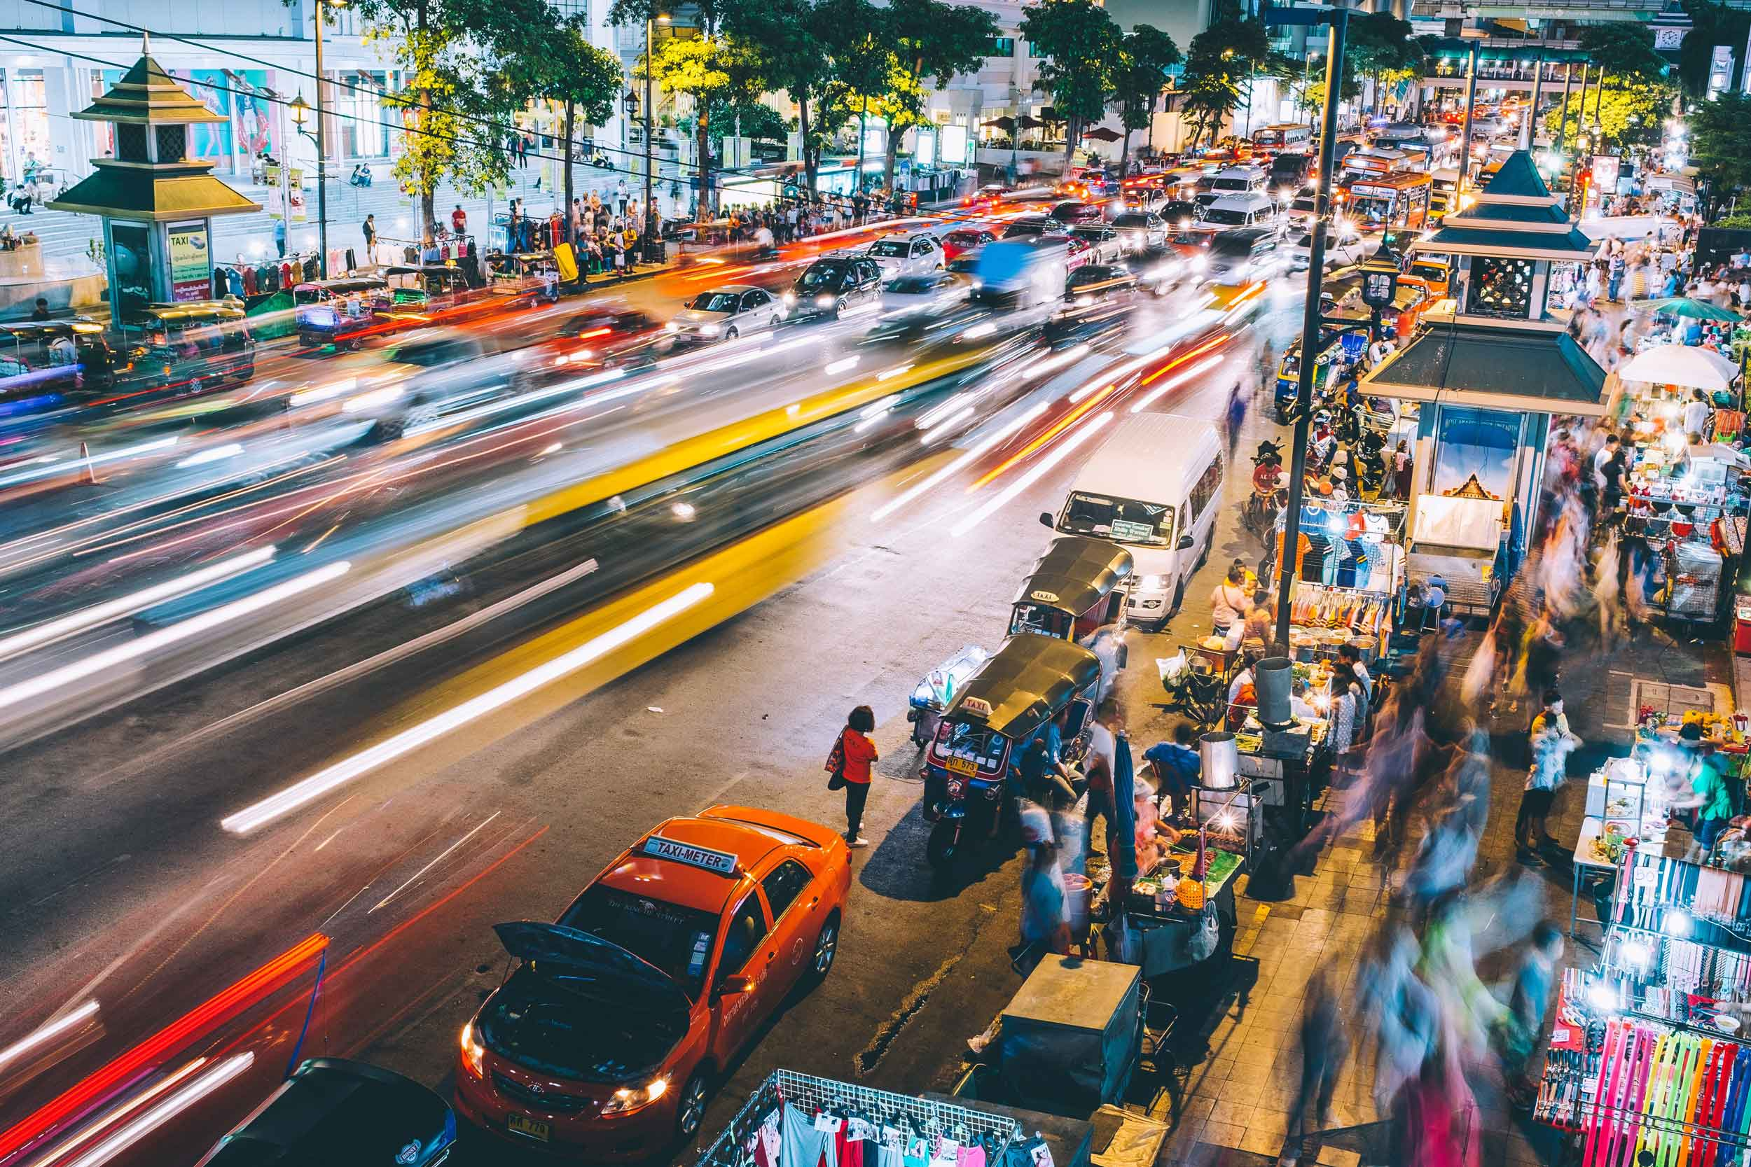

1. Blacklight Photography - Blacklight photography uses ultraviolet light instead of white light. White light is the light produced by standard lamps and flashes. It illuminates the world around us. But black or ultraviolet light can’t be seen by the human eye. Our eyes can’t see black light, but our camera sensors can. And you can use black light in photography to create incredible images with neon colors.

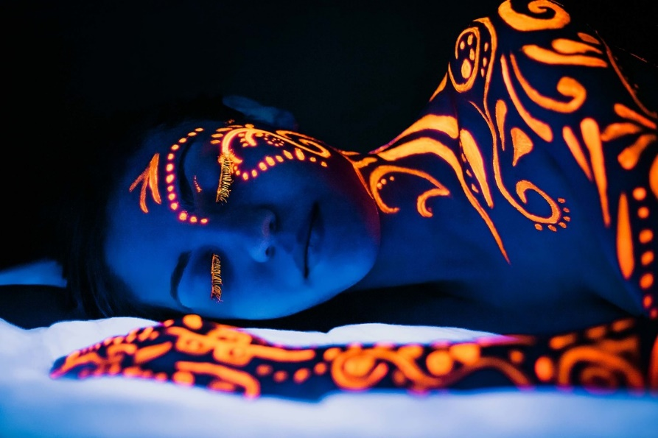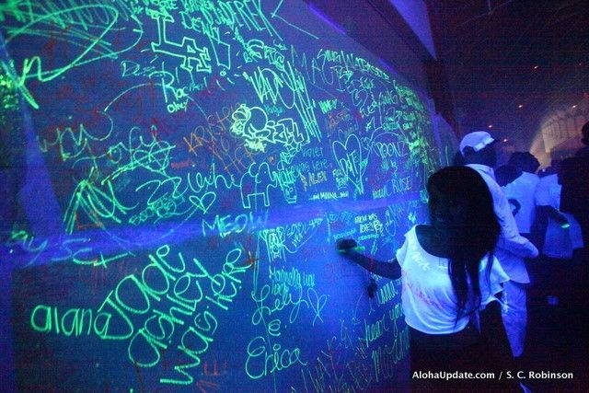

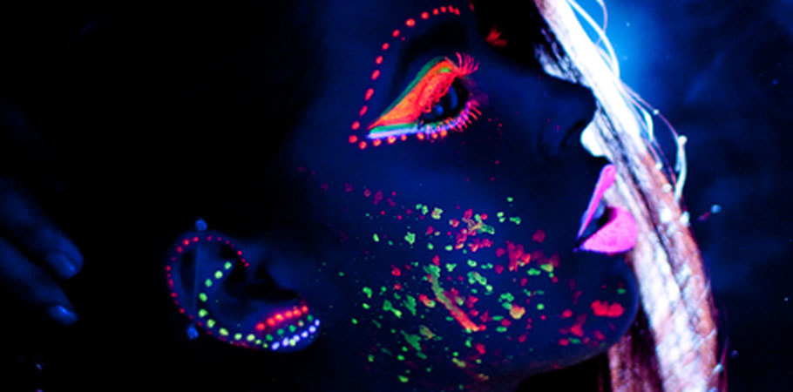

1. Black-and-White Photography
2. Flat Lay Photography - Flat lay photography is where you arrange items on a flat surface and take a photo from above. Your flat surface is the canvas on which you paint your picture. You can create themed images. Or you can use them to send messages.

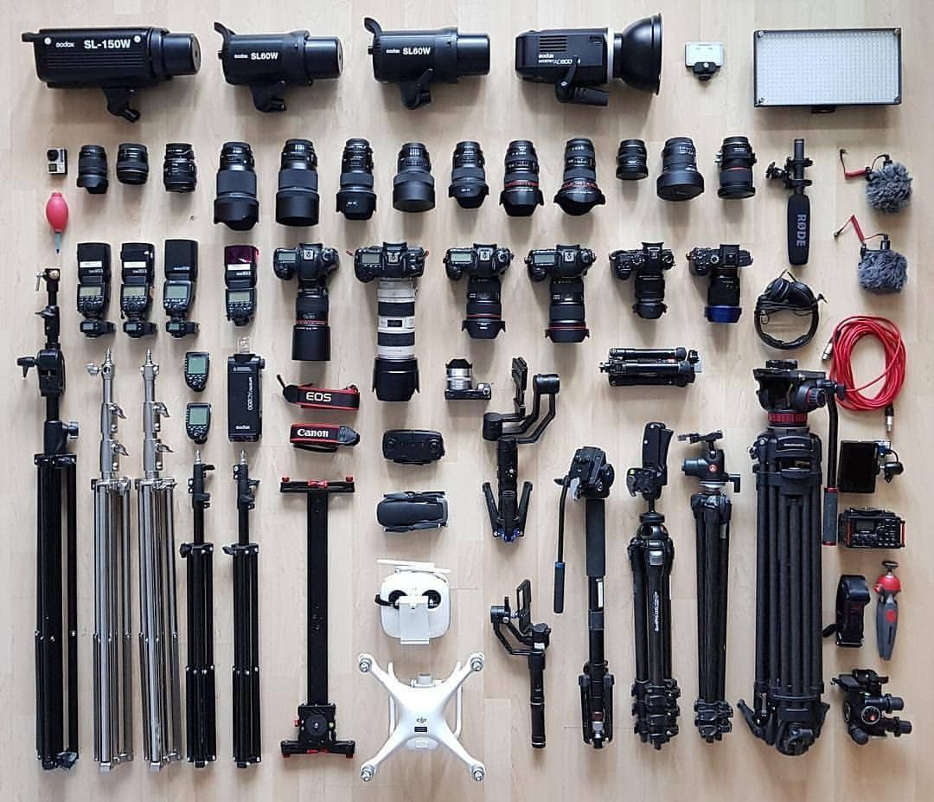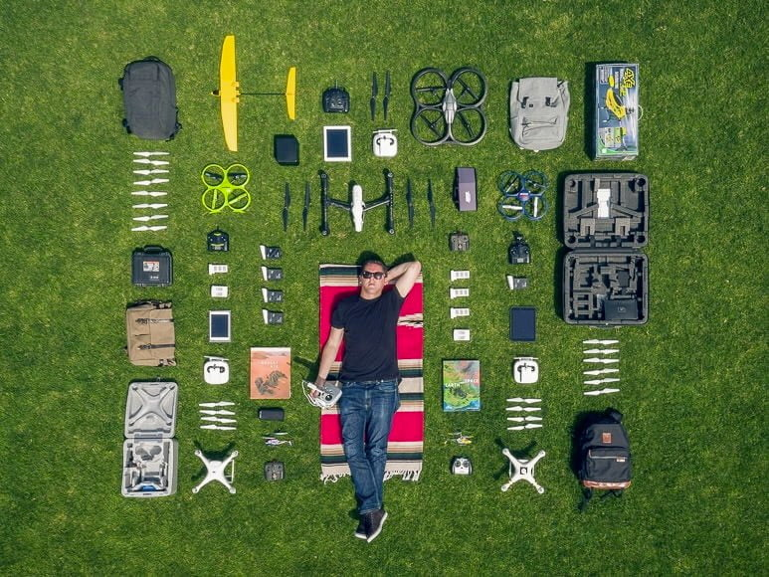



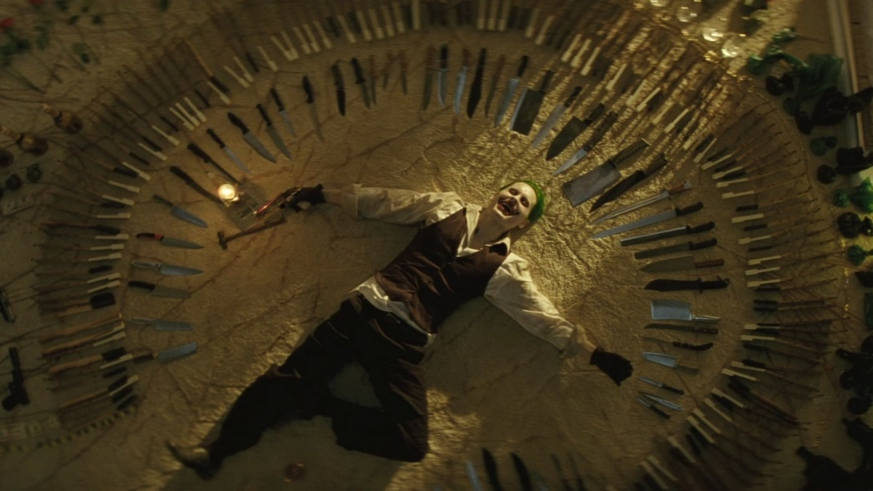

1. High Dynamic Range Photography - High dynamic range (HDR) photography produces images with strong color vibrancy and intense detail. The basic concept is taking several pictures of the same scene, each with different exposure settings. Then you combine them into one image.

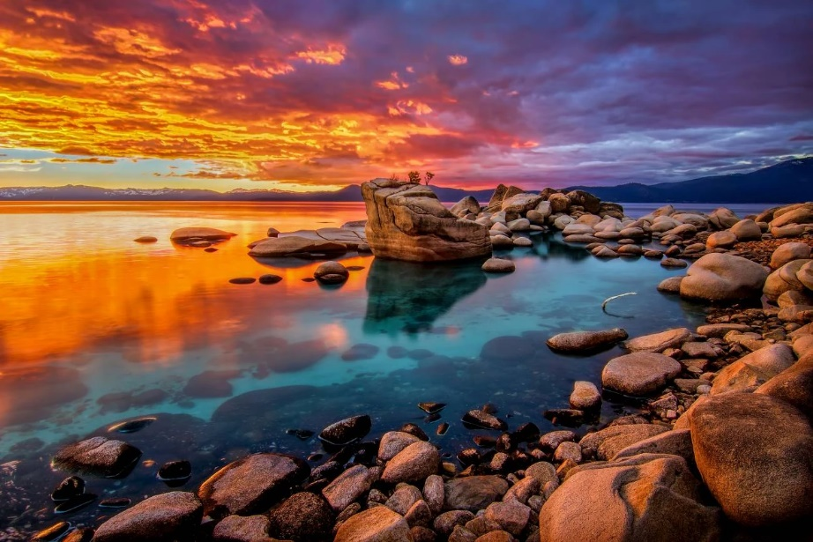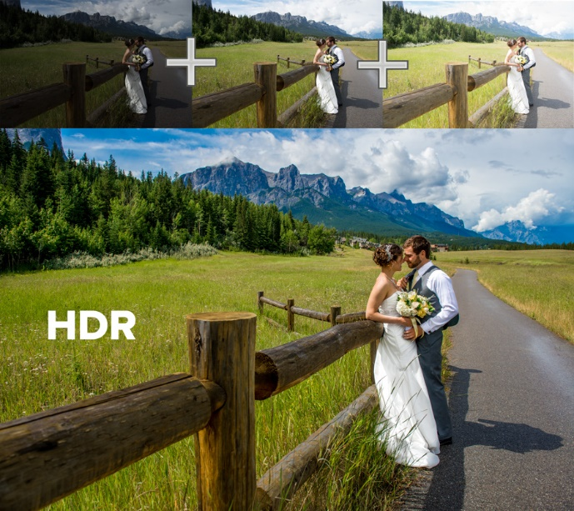

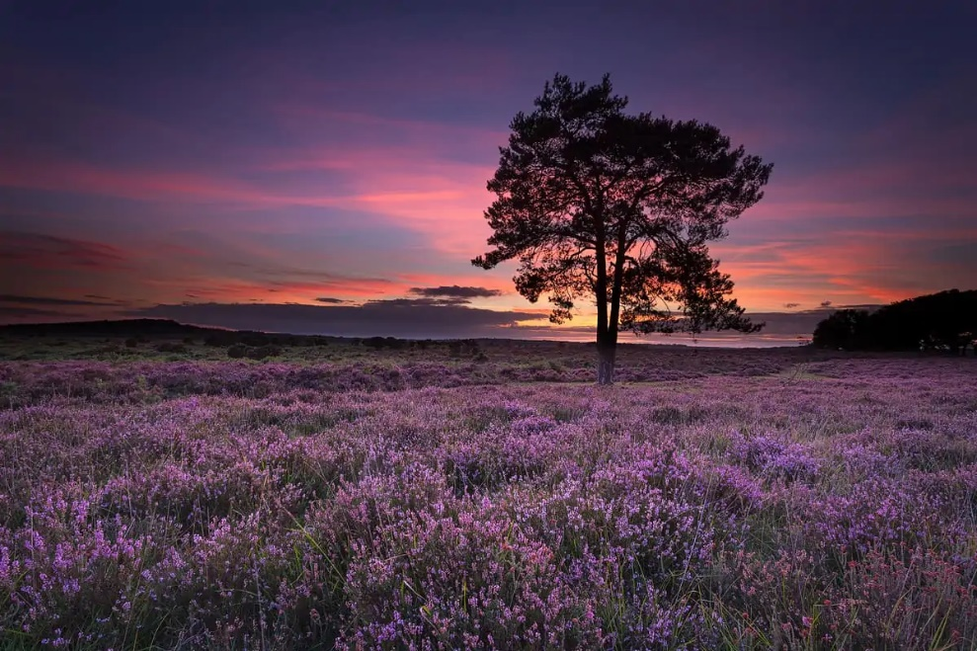

1. Crystal Ball Photography - Crystal ball photography is centered around one specific prop—a crystal ball. They have a magical quality. And they manipulate light, giving you reflections and shapes.

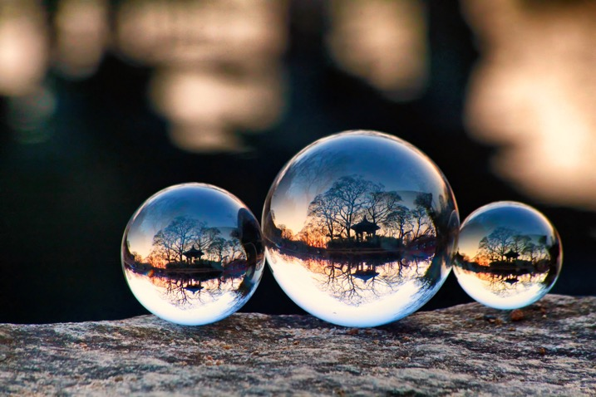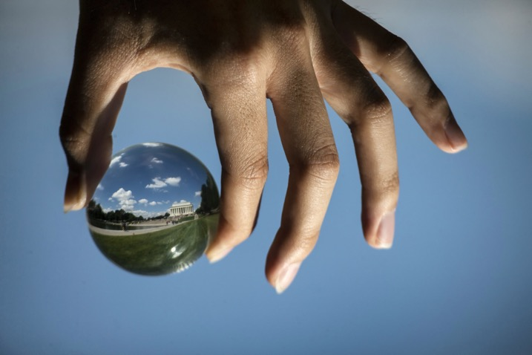

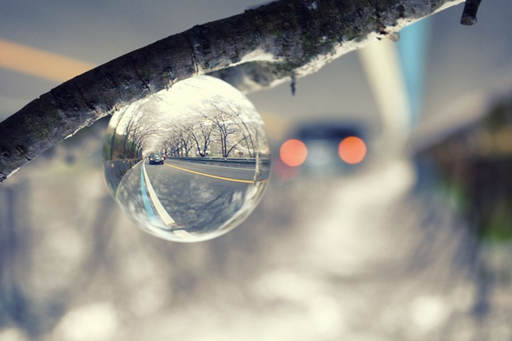

**6. Photography for Business**

1. Product Photography - Product photography is a branch of photography that involves photographing products with the intention of displaying, promoting, and highlighting certain features of a product.

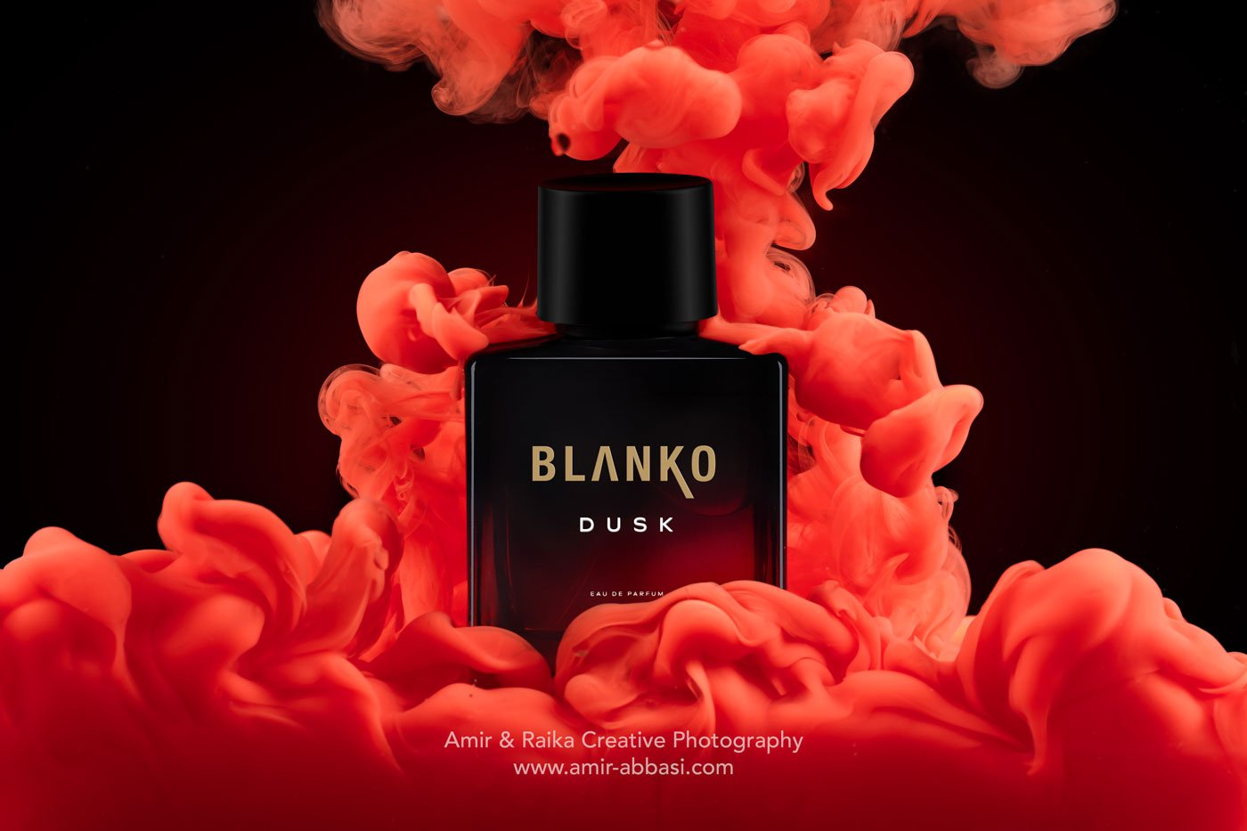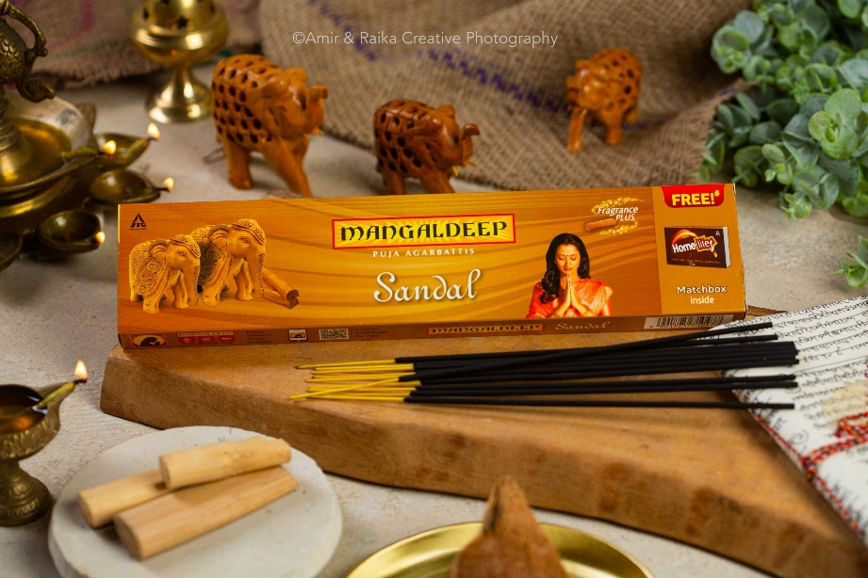

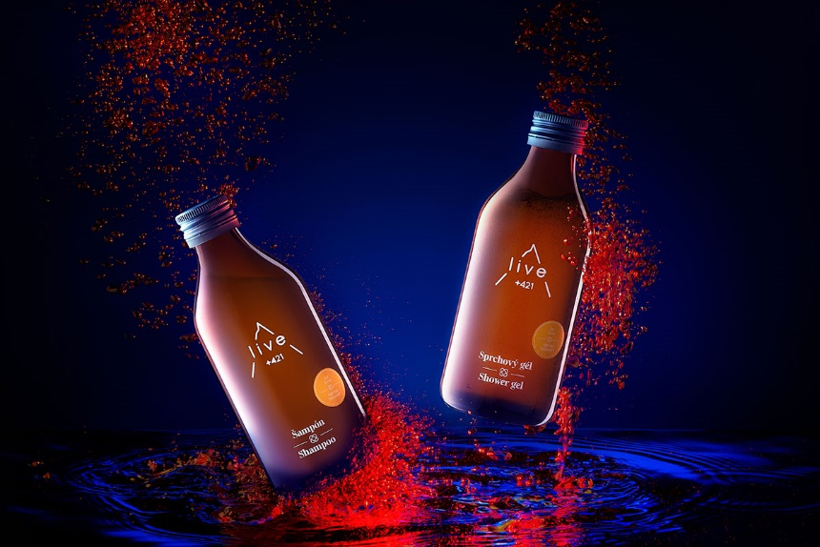

1. Food Photography



1. Architecture Photography - Architecture photography is the art of shooting buildings and other structures. This might be to celebrate the architecture. And the shapes and lines are often highlighted in minimalist or abstract photography.

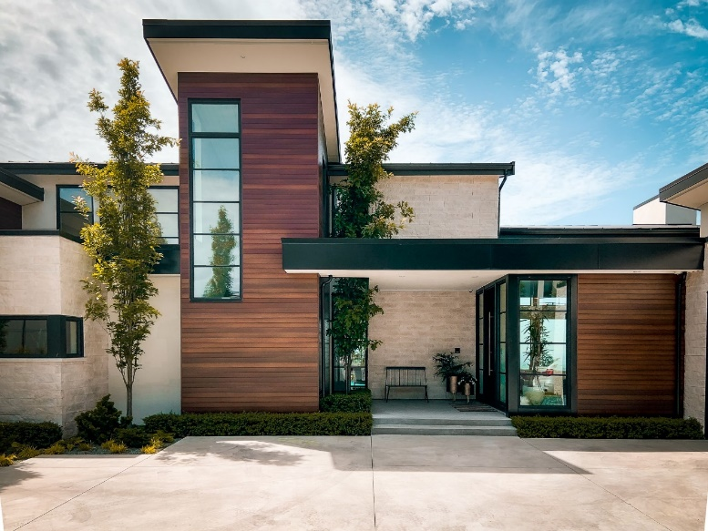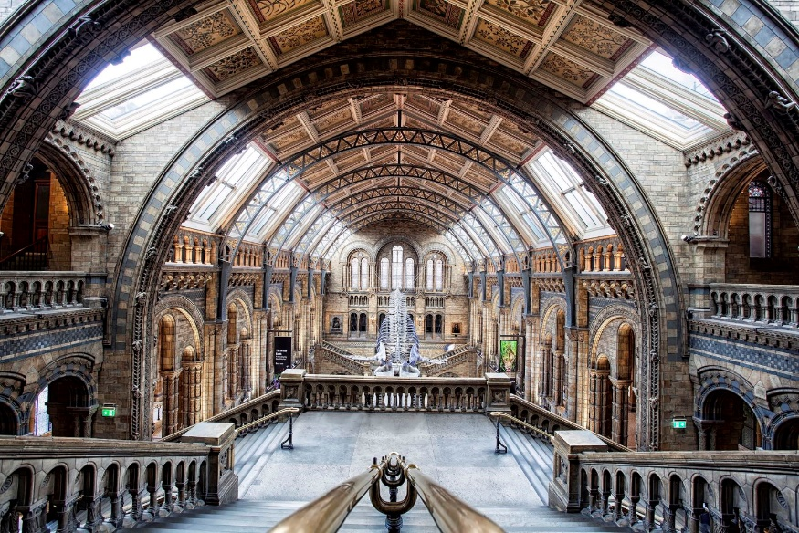

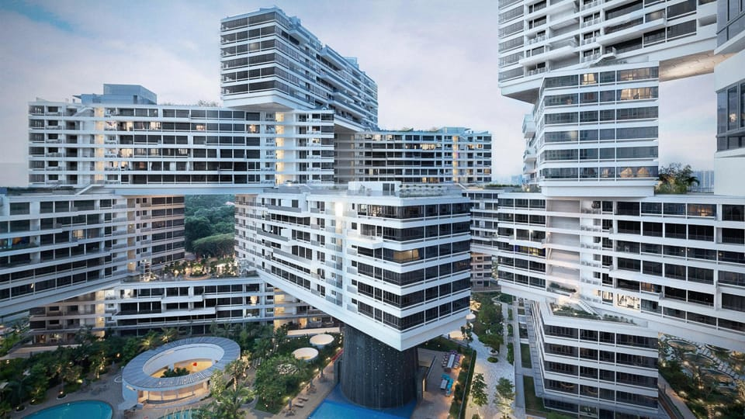

1. Real Estate Photography

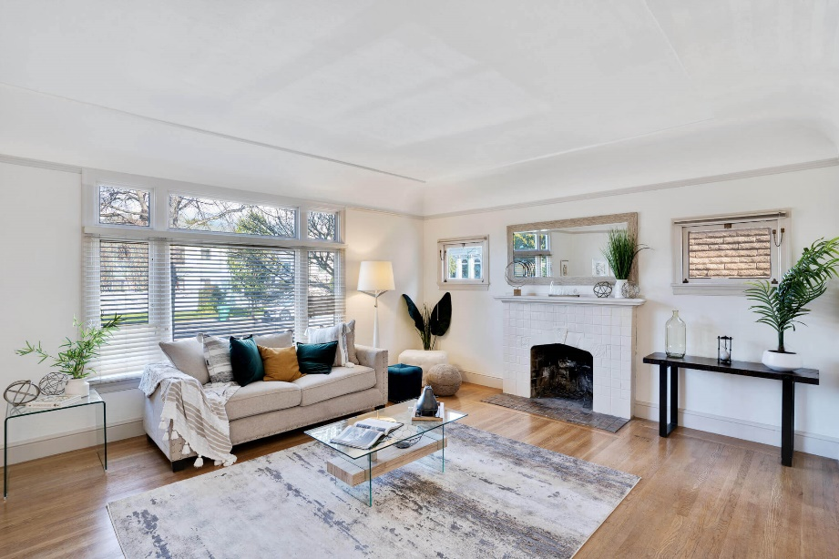

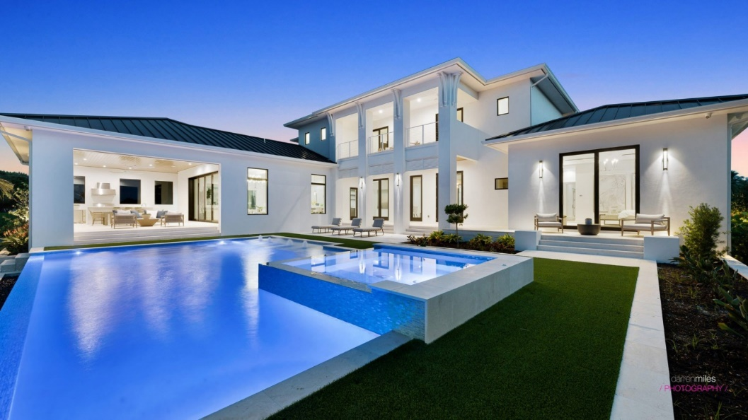

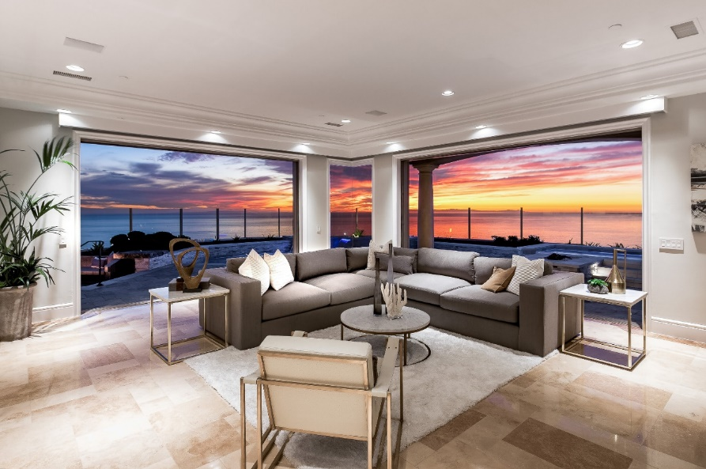

1. Social Media Photography
2. Commercial Photography - Commercial photographers will use portrait, fashion, and product photography.



